7153CEM Dataset Analysis and Visualization Using Big Data Program

Predicting Online Customers Behavior with Machine Learning and Data Visualization

Student Name: Navya Kalyani Anantha

Student ID: 14597727

Student Course Name : Data Science and Computational Intelligence

Student Mail ID: [ananthan2@coventry.ac.uk](mailto:ananthan2@coventry.ac.uk)

TABLE OF CONTENTS

Abstract ------------------ 3

Introduction ------------------- 4

Background/Related work ------------------ 5 - 6

Dataset Section ------------------ 7 - 8

Dataset Visualization using Tableau ----------------- 9 - 11

Methodology ------------------ 12

Experimental Section ------------------- 13 - 14

Result Discussion ------------------- 15 - 16

Conclusion ------------------- 17

Future Works ------------------- 18

Social Impact ------------------ 19

References ------------------- 20

Appendix ------------------- 21-48

1. ABSTRACT

In today's digital age, how we shop has changed drastically, especially with the rise of online shopping. This abstract dives into an analysis of the Online Shoppers Purchasing Intention dataset from the UCI Machine Learning Repository. The main aim is to use smart computer methods to figure out what makes people decide to buy things online.

By using tools like PySpark for handling data and Tableau for making sense of it visually, this study aims to uncover the reasons behind why people click that "buy" button. We'll look at things like how long people spend on a website, what pages they visit, and where they come from online.

Early findings from the dataset suggest that factors like how long someone stays on a site, what pages they check out, and who they are can influence whether they make a purchase. By using these fancy computer techniques and cool visual tools, we hope to give online businesses helpful insights. This could mean better ads, smoother website experiences, and happier customers.

Ultimately, this abstract sets the stage for understanding what drives people to make online purchases. By tapping into the power of data analysis, businesses can get a clearer picture of how people shop online and make changes to improve their online stores accordingly.

**Keywords:** Online shopping, E-commerce, Logistic Regression, Gradient Boosting, Support Vector Machine (SVM), Random Forest, Root Mean Squared Error, Mean Absolute Error, R-squared.

1. INTRODUCTION

In the ever-evolving landscape of e-commerce, understanding online shopper behavior is crucial for businesses to thrive. This project delves into the analysis of the Online Shoppers Purchasing Intention dataset obtained from the UCI Machine Learning Repository. The primary objective is to employ machine learning techniques to predict whether an online shopper is likely to make a purchase or not, based on various features extracted from their browsing behavior.

PySpark, a distributed computing framework for processing large datasets, will be employed for data preprocessing and feature engineering. PySpark offers scalability and efficiency, making it ideal for handling big data tasks. Additionally, scikit-learn, a popular machine learning library in Python, will be leveraged for implementing and evaluating various classification algorithms.

Logistic Regression, Random Forest, Gradient Boosting, and Support Vector Machine (SVM) algorithms will be explored to identify the most effective model for predicting purchasing intention. Each algorithm will be trained and evaluated using appropriate performance metrics to assess its predictive capabilities.

Tableau, a leading data visualization tool, will be utilized to create interactive and informative visualizations. These visualizations will aid in understanding patterns, trends, and correlations within the dataset, as well as communicating the findings effectively to stakeholders.

By combining these tools, algorithms, and visualization techniques, this project aims to provide valuable insights into online shopper behavior, empowering businesses to make informed decisions and enhance the online shopping experience for their customers.

1. BACKGROUND / RELATED WORK

As online shopping continues to grow in popularity, there's a growing interest in understanding how people shop online. With the rise of e-commerce platforms, researchers are increasingly turning to machine learning techniques to delve into online shopper behavior. This shift is fueled by datasets like the "Online Shoppers Purchasing Intention" dataset, which provides valuable insights into the dynamics of online shopping. Leveraging these datasets, researchers aim to uncover patterns, trends, and factors influencing online purchasing decisions.

Researchers have conducted various studies exploring different aspects of online shopper behavior using machine learning approaches. These studies draw from datasets similar to the "Online Shoppers Purchasing Intention" dataset and aim to shed light on key aspects of online shopping behavior:

1. Predictive Modeling for Purchase Intentions: Studies have employed predictive modeling techniques to anticipate whether online shoppers are likely to make a purchase. By analyzing browsing history, demographic information, and website interactions, researchers aim to predict the likelihood of a purchase.
2. Feature Importance Analysis: Researchers have conducted analyses to identify the most influential factors affecting online purchasing decisions. These analyses explore the significance of website attributes such as page views, bounce rates, and page values in determining purchase intentions.
3. Comparative Evaluation of Algorithms: Comparative studies have been conducted to assess the performance of different machine learning algorithms in predicting online shopper behavior. By comparing algorithms like logistic regression, random forest, and gradient boosting, researchers seek to identify the most effective approach.
4. Temporal Analysis of Shopping Patterns: Some studies have focused on analyzing how online shopping behavior evolves over time. By examining seasonal trends, holiday effects, and weekday/weekend variations, researchers aim to gain insights into the temporal dynamics of online shopping.
5. Business Insights and Recommendations: Researchers have provided actionable insights and recommendations for e-commerce businesses based on their analysis of online shopper behavior. These recommendations aim to improve marketing strategies, website optimization, and overall customer engagement to enhance the online shopping experience.

Overall, the body of research in this area contributes to a deeper understanding of online shopper behavior and provides valuable insights for businesses seeking to optimize their e-commerce strategies.

1. DATASET SECTION

The source of my dataset : <https://archive.ics.uci.edu/dataset/468/online+shoppers+purchasing+intention+dataset>

The Online Shoppers Purchasing Intention Dataset, available from the UCI Machine Learning Repository, offers valuable insights into the online shopping behavior of visitors on a leading e-commerce website. This dataset comprises a comprehensive collection of attributes derived from web analytics and customer information, providing a rich source for analyzing and understanding the factors influencing visitors' purchasing intentions.

Here's an overview of the dataset:

**Number of Rows:** The dataset contains a total of 12,330 rows or instances. Each row represents a unique online shopping session or interaction.

**Number of Columns:** The dataset comprises 18 columns or attributes. These columns capture various aspects of the online shopping sessions, including demographic information, website interaction metrics, and indicators of purchase intention.

The dataset includes both numerical and categorical attributes, offering a rich source of information for analyzing online shopper behavior and predicting purchasing intentions. Researchers and analysts can leverage this dataset to explore patterns, trends, and factors influencing online purchasing decisions, as well as to develop machine learning models for predictive analytics and business insights.

Here's a table of the variables with their corresponding roles, types, descriptions, units, and missing values:

|  |  |  |  |  |  |
| --- | --- | --- | --- | --- | --- |
| **Variable Name** | **Role** | **Type** | **Description** | **Units** | **Missing Values** |
| **Month** | Feature | Categorical | Month of the year when the online visit occurred | - | No |
| **OperatingSystems** | Feature | Integer | Operating system used by the visitor | - | No |
| **Browser** | Feature | Integer | Type of browser utilized by the visitor | - | No |
| **Region** | Feature | Integer | Geographical region of the visitor | - | No |
| **TrafficType** | Feature | Integer | Type of traffic that led the visitor to the website | - | No |
| **VisitorType** | Feature | Categorical | Type of visitor, whether returning or new | - | No |
| **Weekend** | Feature | Binary | Whether the visit occurred on a weekend or not | - | No |
| **Revenue** | Target | Binary | Indicates whether the visit resulted in revenue generation | - | No |
| **Administrative** | Feature | Integer | Number of administrative pages visited during the session | - | No |
| **Administrative_Duration** | Feature | Integer | Total time spent on administrative pages during session | - | No |
| **Informational** | Feature | Integer | Number of informational pages visited during the session | - | No |
| **Informational_Duration** | Feature | Integer | Total time spent on informational pages during session | - | No |
| **ProductRelated** | Feature | Integer | Number of product-related pages visited during session | - | No |
| **ProductRelated_Duration** | Feature | Continuous | Total time spent on product-related pages during session | - | No |
| **BounceRates** | Feature | Continuous | Bounce rate, i.e., percentage of visitors who leave after viewing one page | - | No |
| **ExitRates** | Feature | Continuous | Exit rate, i.e., percentage of visitors who leave from a specific page | - | No |
| **PageValues** | Feature | Integer | Average value of a page visited before completing a transaction | - | No |
| **SpecialDay** | Feature | Integer | Indicates proximity of the visit to special days (e.g., holidays) | - | No |

*Table 1: About Dataset*

* 1. Dataset Visualisation using Tableau

Univariate analysis

1. Revenue with shoppers count

Revenue coming from the only 1908 customers

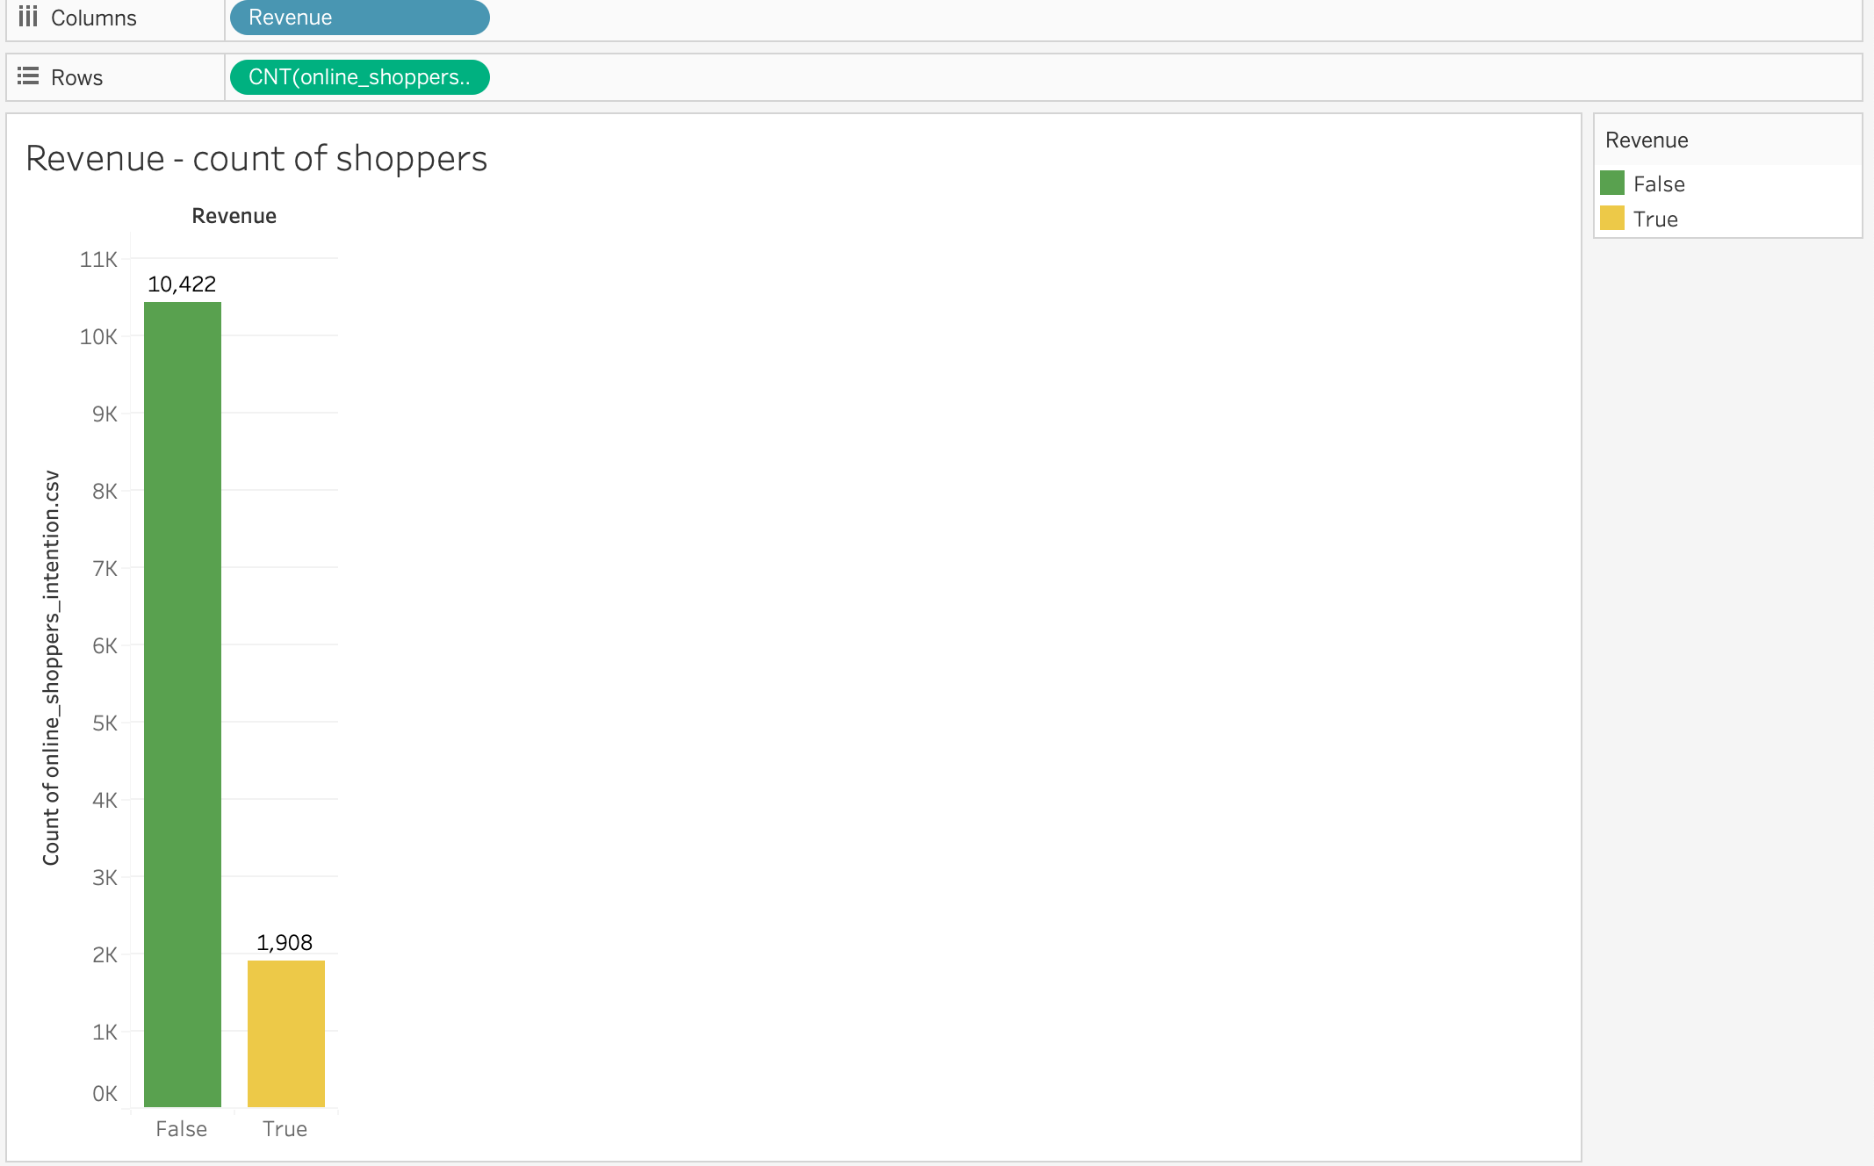

*Figure 1: Revenue with shoppers count Bar graph*

1. Percentage of Online shoppers with Visitor Type

Returning visitor visiting online are more than the new visitors

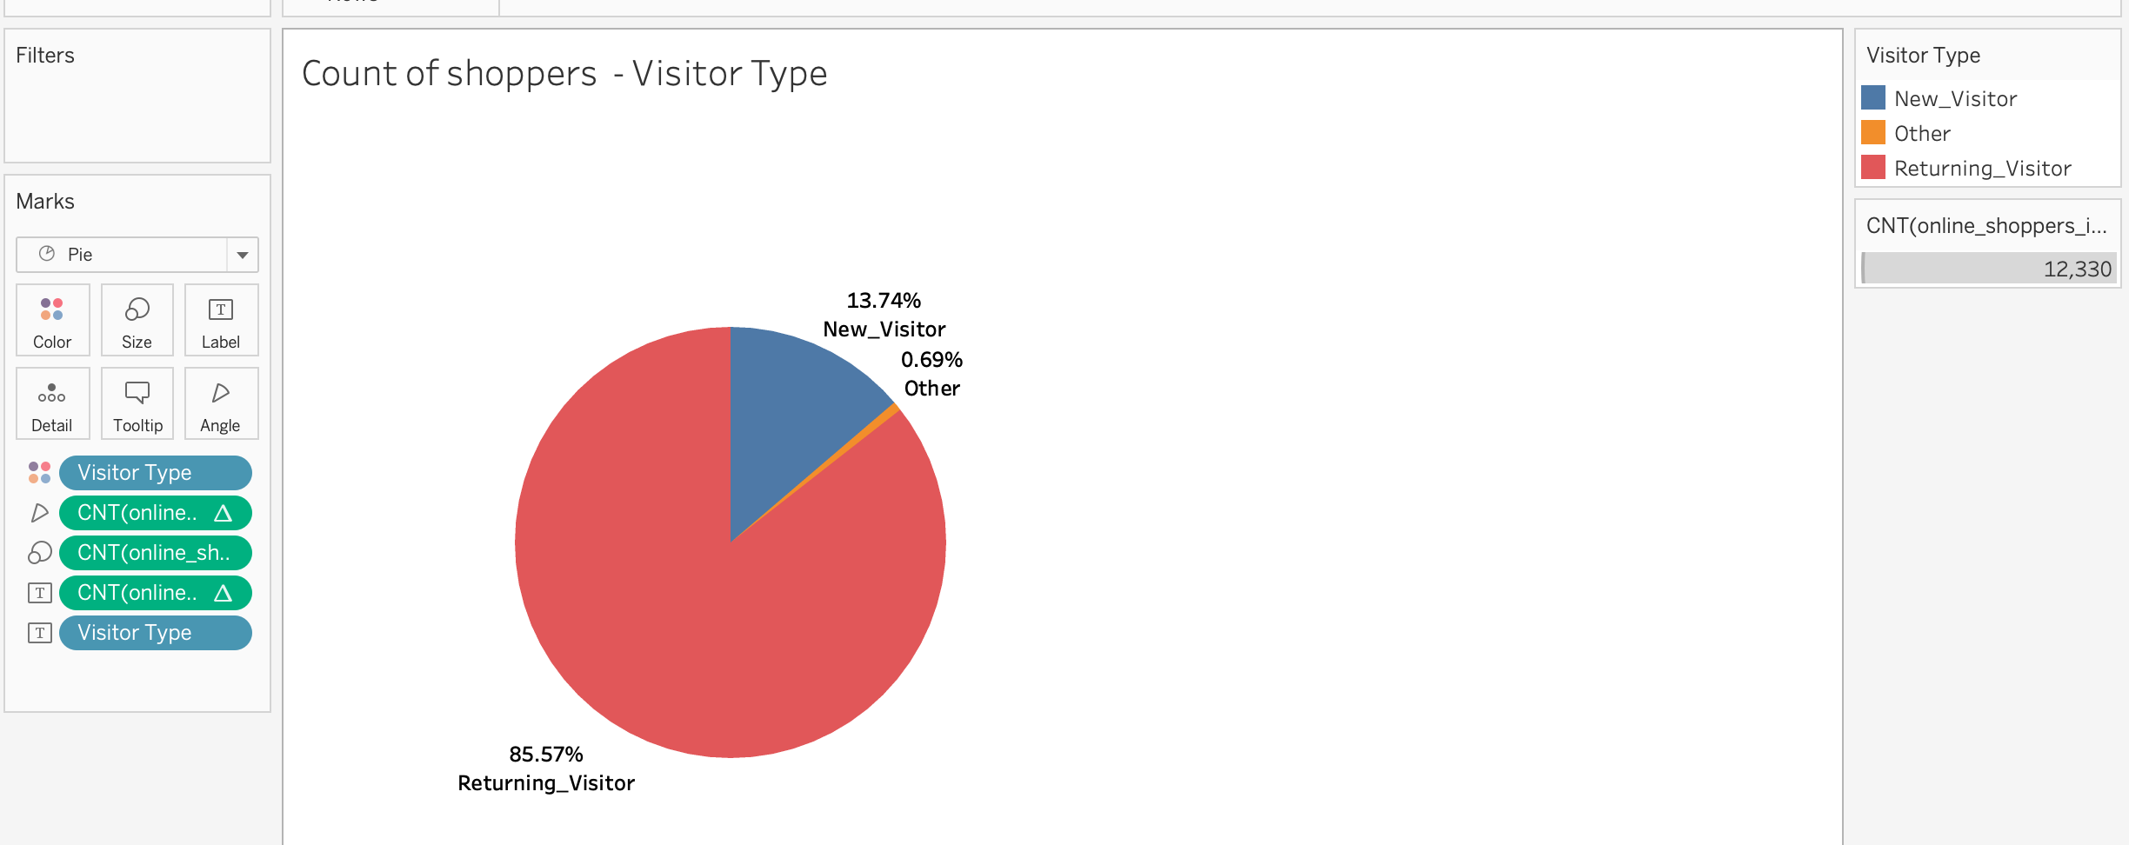

*Figure 2: Pie Diagram showing the percentage of online shoppers with Visitor Type*

1. Month vs count of online shoppers

Customers buying online in the Month of May mostly

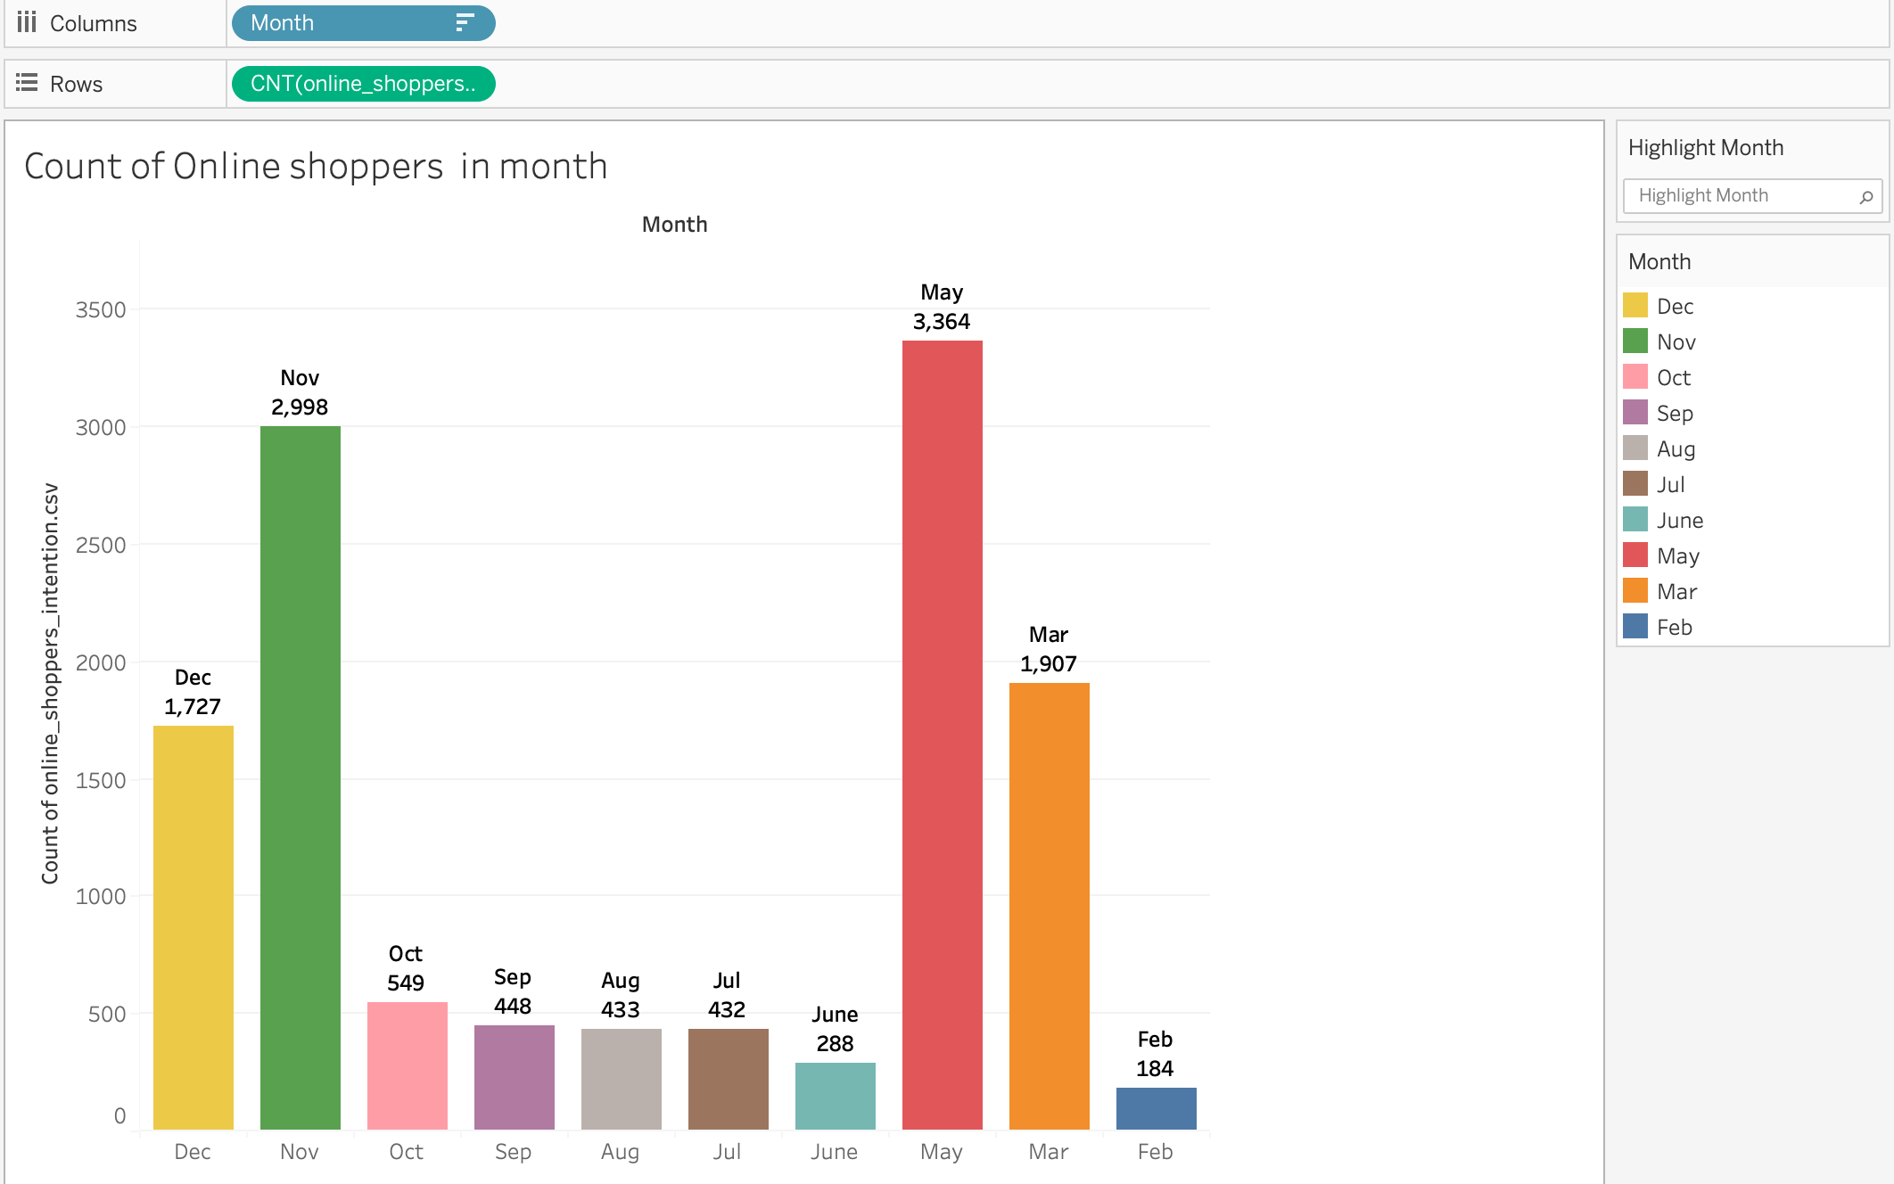

*Figure 3: Bar graph showing the count of online shoppers on basis of Month*

Algorithm results

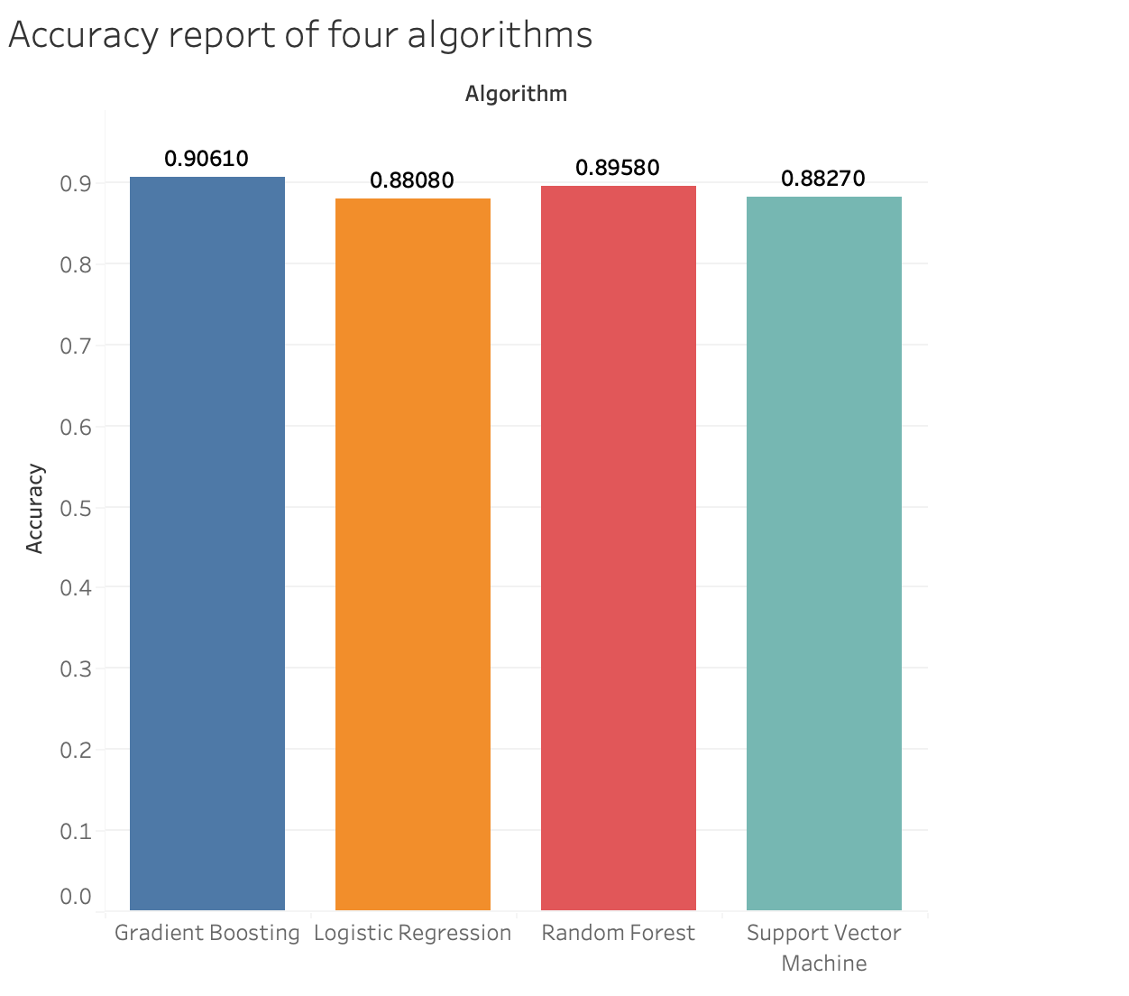

*Figure 4: Bar graph showing the accuracy report of four ML algorithms*

1. METHODOLOGY

**Logistic Regression:**

Logistic Regression is a popular linear classification algorithm that models the probability of a binary outcome based on one or more predictor variables. It predicts the probability that an instance belongs to a particular class.(H Seyedpoor, F. D. Torre, A. R. R. Heshmati, 2021).

**Random Forest:**

Random Forest is an ensemble learning method that builds a multitude of decision trees during training and outputs the class that is the mode of the classes (classification) or mean prediction (regression) of the individual trees. (L. Breiman, 2001 ; A. Liaw, M. Wiener, 2002).

Gradient Boosting:

Gradient Boosting is an ensemble learning technique that builds a strong model by sequentially adding weak learners (decision trees) to correct the errors of the previous models. It optimizes a differentiable loss function using gradient descent. (J. H. Friedman, 2001 ; A. S. Neill, 2014).

**Support Vector Machine (SVM):**

Support Vector Machine is a powerful supervised learning algorithm used for classification tasks. It finds the hyperplane that best separates the data into different classes while maximizing the margin between the classes. (C. J. C. Burges, 1998).

1. EXPERIMENTAL SECTION

The following methodology outlines our approach:

**Environment Setup:**

We initiated our experiment by installing essential packages, including PySpark and Findspark, through the pip package manager within the Google Colab environment. (Figure: 11)

**Data Handling:**

Initially, we imported the online shopper dataset from the UCI Machine Learning Repository into a PySpark DataFrame.

To comprehend the dataset's structure, we examined its schema and provided a snapshot of the data to ensure proper loading.

Essential preprocessing tasks such as handling missing values and encoding categorical variables were performed using PySpark functionalities. (Figure: 12 – 17.1)

|  |  |  |
| --- | --- | --- |
|  | Weekend | Revenue |
| TRUE | 1 | 1 |
| FALSE | 0 | 0 |

**Feature Engineering:**

PySpark's feature engineering capabilities were harnessed to aggregate feature columns and transform the data into a suitable format for model training.

Categorical feature encoding was achieved using StringIndexer and OneHotEncoder, while VectorAssembler facilitated the creation of a feature vector. (Figure: 18 – 19)

|  |  |  |
| --- | --- | --- |
| Visitor Type | Visitor_Index | Vistor_Encoded |
| Returning_Visitor | 0.0 | {0: 1.0} |
| New_Visitor | 1.0 | {1: 1.0} |
| Other | 2.0 | {} |

**Correlation Analysis:**

A heatmap visualization was employed to interpret the correlation matrix. This helped in identifying patterns and potential multicollinearity issues. Heatmap colors indicated strength and direction of correlations between features. Strong positive or negative correlations were identified. (Figure: 22)

**Model Training:**

The dataset was partitioned into training and testing subsets (70% and 30%, respectively) employing PySpark's randomSplit function.

Subsequently, we trained four distinct classification models, namely Logistic Regression, Random Forest, Gradient-Boosted Tree, and Support Vector Machine (SVM), utilizing PySpark's machine learning algorithms. (Figure: 23 - 25)

**Model Evaluation:**

The performance of each trained model was evaluated using accuracy metrics for classification tasks and regression metrics for regression tasks. Accuracy scores on the test dataset were computed for classification models using MulticlassClassificationEvaluator, while regression metrics (RMSE, R2, and MAE) were calculated using RegressionEvaluator. (Figure: 26)

**Results and Analysis:**

We presented the accuracy scores of each classification model and conducted a comparative analysis of their relative performance.

Furthermore, regression metrics were analyzed to assess the predictive efficacy of the models in terms of RMSE, R2, and MAE. (Figure: 29)

**Visualization:**

The accuracy scores of various classification models were visualized using a bar graph to facilitate comparison and interpretation.

(Figure: 32 – 34).

1. RESULT DISCUSSION

In our classification analysis using the Online Shopper's Intention dataset, we employed four machine learning algorithms: Logistic Regression, Random Forest, Gradient Boosting, and Support Vector Machine (SVM), to predict online shoppers' intention to make a purchase. Each algorithm was trained and evaluated based on a set of features extracted from the dataset, with the target variable being the "Revenue" label indicating whether a purchase was made.

**Features Used:** Administrative, Administrative_Duration, Informational, Informational_Duration, ProductRelated, ProductRelated_Duration, BounceRates, ExitRates, PageValues, SpecialDay, Month_index, VisitorType_index, Month_encoded, VisitorType_encoded.

Here are the key findings from our analysis:

**Logistic Regression:**

Logistic Regression achieved a decent accuracy of 88.08%, indicating its effectiveness in predicting online shoppers' purchase intentions. However, the RMSE, R-squared, and MAE scores suggest moderate predictive performance.

**Random Forest:**

Random Forest demonstrated higher accuracy (89.58%) compared to Logistic Regression. Additionally, it exhibited lower RMSE, higher R-squared, and lower MAE, indicating improved predictive performance and better fit to the data.

Gradient Boosting:

Gradient Boosting outperformed both Logistic Regression and Random Forest with the highest accuracy of 90.61%. It achieved the lowest RMSE, highest R-squared, and lowest MAE scores, indicating superior predictive accuracy and model fit

**Support Vector Machine (SVM):**

SVM demonstrated competitive performance with an accuracy of 88.27%. However, its RMSE, R-squared, and MAE scores were slightly higher compared to Random Forest and Gradient Boosting, indicating relatively weaker predictive accuracy and model fit.

|  |  |  |  |  |
| --- | --- | --- | --- | --- |
| **Algorithm** | **Accuracy** | **Root Mean Squared Error** | **R-squared** | **Mean Absolute Error** |
| **Logistic Regression** | 88.08% | 0.3453 | 11.70% | 0.1192 |
| **Random Forest** | 89.58% | 0.3292 | 19.72% | 0.1084 |
| **Gradient Boosting** | 90.61% | 0.3065 | 30.43% | 0.0939 |
| **Support Vector Machine** | 88.27% | 0.3425 | 13.14% | 0.1173 |

*Table 2: Display the Accuracies and Metrics results*

Overall, Gradient Boosting achieved the highest accuracy score of 0.9061, indicating its effectiveness in predicting online shoppers' purchase intentions. Additionally, it exhibited the lowest RMSE, highest R-squared, and lowest MAE among all algorithms, suggesting better performance in terms of regression metrics.

These results emphasize the importance of choosing an appropriate machine learning algorithm and feature set for accurately predicting online shoppers' behavior and optimizing e-commerce strategies to maximize revenue generation.

1. CONCLUSION

In today's world, where e-commerce continues to thrive and online shopping behavior evolves rapidly, understanding online shoppers' intentions is crucial for businesses to stay competitive. This project aimed to analyze online shoppers' intentions using machine learning algorithms and dataset features.

Through our analysis, we found that employing advanced classification algorithms such as Gradient Boosting and Random Forest yielded the most accurate predictions of online shoppers' purchase intentions. These models effectively utilized various features from the dataset, including administrative, informational, and product-related attributes, to classify whether a visitor is likely to make a purchase.

Features such as administrative, informational, and product-related attributes played significant roles in determining online shoppers' purchase intentions. The analysis revealed that these features had the most substantial impact on the classification outcomes, highlighting their importance in understanding consumer behavior in the e-commerce domain.

The dynamic nature of online shopping behavior necessitates continuous adaptation by businesses to stay relevant and competitive. Machine learning models trained on online shopper datasets enable businesses to adapt to changing consumer preferences, market trends, and competitive landscapes effectively.

1. FUTURE WORKS

The future work of this project encompasses several avenues for advancing the prediction accuracy and interpretability of online shopper intention models. Firstly, exploring deep learning methodologies, including deep neural networks (DNNs), recurrent neural networks (RNNs), and convolutional neural networks (CNNs), can capture intricate patterns in online shopping data, potentially enhancing prediction accuracy. Additionally, incorporating Long Short-Term Memory (LSTM) networks can help model sequential dependencies in shopper behavior, improving the model's ability to capture temporal patterns effectively. Further refinement of feature engineering techniques, including the exploration of additional features and leveraging domain knowledge, can extract more meaningful insights from the dataset, enriching the model's predictive capabilities.

Moreover, employing ensemble learning techniques such as bagging, boosting, and stacking can combine predictions from multiple models to enhance prediction accuracy and robustness. Prioritizing model interpretability through techniques like feature importance analysis and SHAP values is crucial for understanding the factors driving shopper intentions and gaining actionable insights. Overall, future work in this project aims to leverage advanced machine learning methodologies to drive improvements in decision-making processes for e-commerce businesses, ultimately enhancing customer engagement and revenue generation while ensuring transparent and ethical data practices.

1. SOCIAL AND ETHICAL IMPACT

The project on predicting online shopper intentions through machine learning introduces several social and ethical considerations. Firstly, there are privacy concerns regarding the collection and processing of personal data, emphasizing the need for robust security measures to safeguard individuals' information. Additionally, machine learning algorithms must mitigate algorithmic biases present in training data to prevent discriminatory outcomes across demographic groups. Ensuring informed consent from individuals before using their data is crucial, along with transparent communication about data usage and potential implications. Moreover, businesses must prioritize consumer trust by implementing transparent data practices and respecting individuals' autonomy in their online experiences. Regulatory compliance with data protection laws further underscores the importance of ethical data handling. Ultimately, businesses bear a social responsibility to use predictive modeling ethically, promoting diversity and inclusion while enhancing customer experiences and respecting individual rights and freedoms.

1. REFERENCES
2. Budnikas, G. (2015). Computerised recommendations on e-transaction finalisation by means of machine learning. *Statistical Transportation Research*, 16(2), 309–322.
3. Ho, T. K. (1995). Random decision forests. In *Proceedings of 3rd international conference on document analysis and recognition* (Vol. 1, pp. 278–282).
4. Vapnik, Vladimir N. (1997). Gerstner, Wulfram; Germond, Alain; Hasler, Martin; Nicoud, Jean-Daniel (eds.). ["The Support Vector method"](https://link.springer.com/chapter/10.1007/BFb0020166). *Artificial Neural Networks — ICANN'97*. Berlin, Heidelberg: Springer: 261–271. [doi](https://en.wikipedia.org/wiki/Doi_(identifier)):[10.1007/BFb0020166](https://doi.org/10.1007/BFb0020166). [ISBN](https://en.wikipedia.org/wiki/ISBN_(identifier)) [978-3-540-69620-9](https://en.wikipedia.org/wiki/Special:BookSources/978-3-540-69620-9).
5. Moe, W. W. (2003). Buying, searching, or browsing: Differentiating between online shoppers using in-store navigational clickstream. *Journal of Consumer Psychology*, 13(1–2), 29–39. <https://doi.org/10.1207/153276603768344762>.
6. Hardy, Quentin (June 13, 2014). ["Tableau Software Helping Data Become More Visual"](https://archive.nytimes.com/bits.blogs.nytimes.com/2014/06/13/tableau-software-helps-data-become-more-visual/). *Bits Blog*. Retrieved May 9, 2023.
7. Mason, L.; Baxter, J.; Bartlett, P. L.; Frean, Marcus (1999). ["Boosting Algorithms as Gradient Descent"](http://papers.nips.cc/paper/1766-boosting-algorithms-as-gradient-descent.pdf) (PDF). In [S.A. Solla](https://en.wikipedia.org/wiki/Sara_Solla) and T.K. Leen and K. Müller (ed.). *Advances in Neural Information Processing Systems 12*. MIT Press. pp. 512–518.
8. ["Feature engineering in Machine Learning"](https://web.archive.org/web/20160304112056/https:/ufal.mff.cuni.cz/~zabokrtsky/courses/npfl104/html/feature_engineering.pdf) (PDF). Zdenek Zabokrtsky. Archived from [the original](https://ufal.mff.cuni.cz/~zabokrtsky/courses/npfl104/html/feature_engineering.pdf) (PDF) on 4 March 2016. Retrieved 12 November 2015.
9. Kohavi and F. Provost, "Glossary of terms", Machine Learning, vol. 30, no. 2–3, pp. 271–274, 1998. IEEE Transactions on Pattern Analysis and Machine Intelligence". 2021 *Journal Citation Reports*. Web of Science (Science ed.). *Clarivate Analytics*. 2022.
10. Sakar, C. O., Polat, S. O., Katircioglu, M., & Kastro, Y. (2019). Real-time prediction of online shoppers’ purchasing intention using multilayer perceptron and LSTM recurrent neural networks. *Neural Computing and Applications*, 31(10), 6893–6908. <https://doi.org/10.1007/s00521-018-3523-0>.
11. ["Spark Release 2.0.0"](https://spark.apache.org/releases/spark-release-2-0-0.html). MLlib in R: SparkR now offers MLlib APIs [..] Python: PySpark now offers many more MLlib algorithms".
12. ["Spark 2.2.0 Quick Start"](https://spark.apache.org/docs/2.2.0/quick-start.html). apache.org. 2017-07-11. Retrieved 2017-10-19. we highly recommend you to switch to use Dataset, which has better performance than RDD
13. APPENDIX

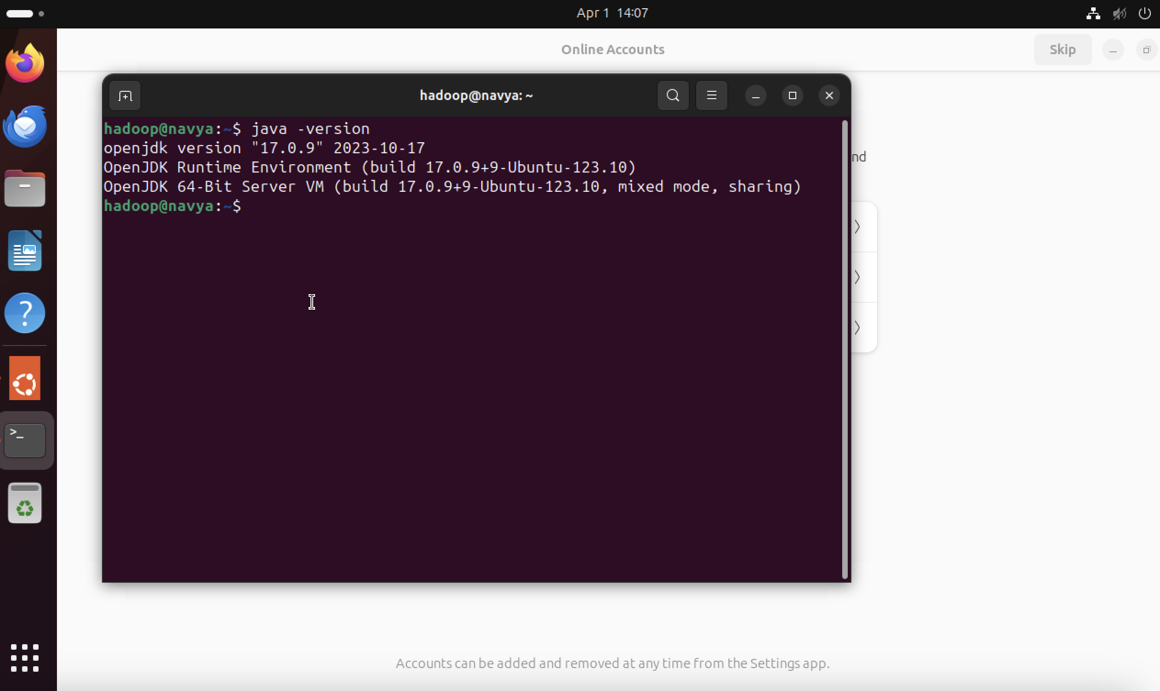

*Figure 5: Java Version*

Hadoop 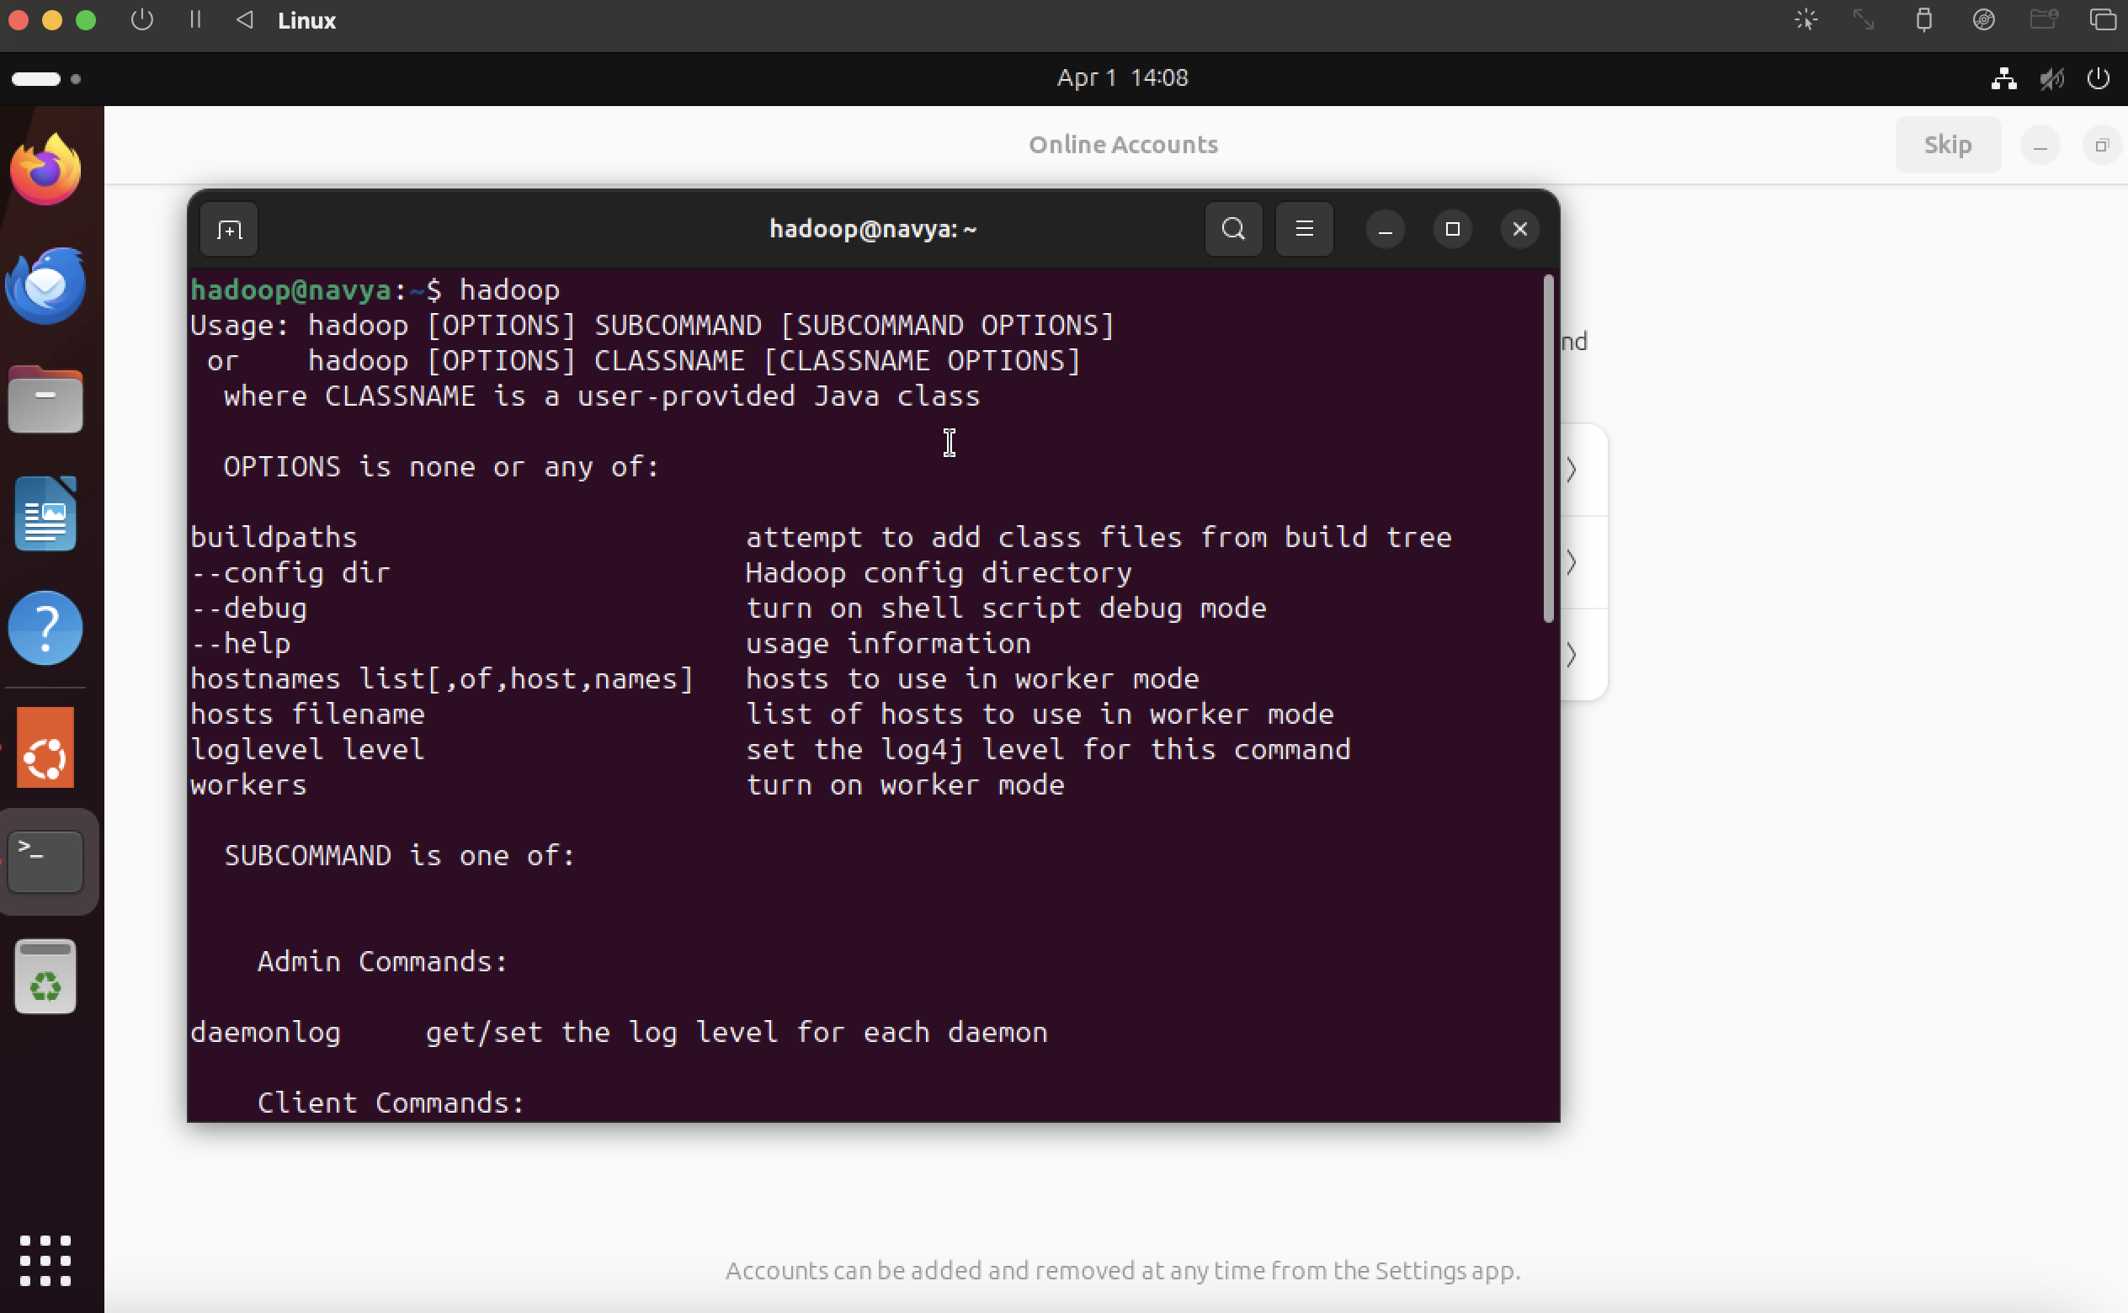

*Figure 6: Executing Hadoop*

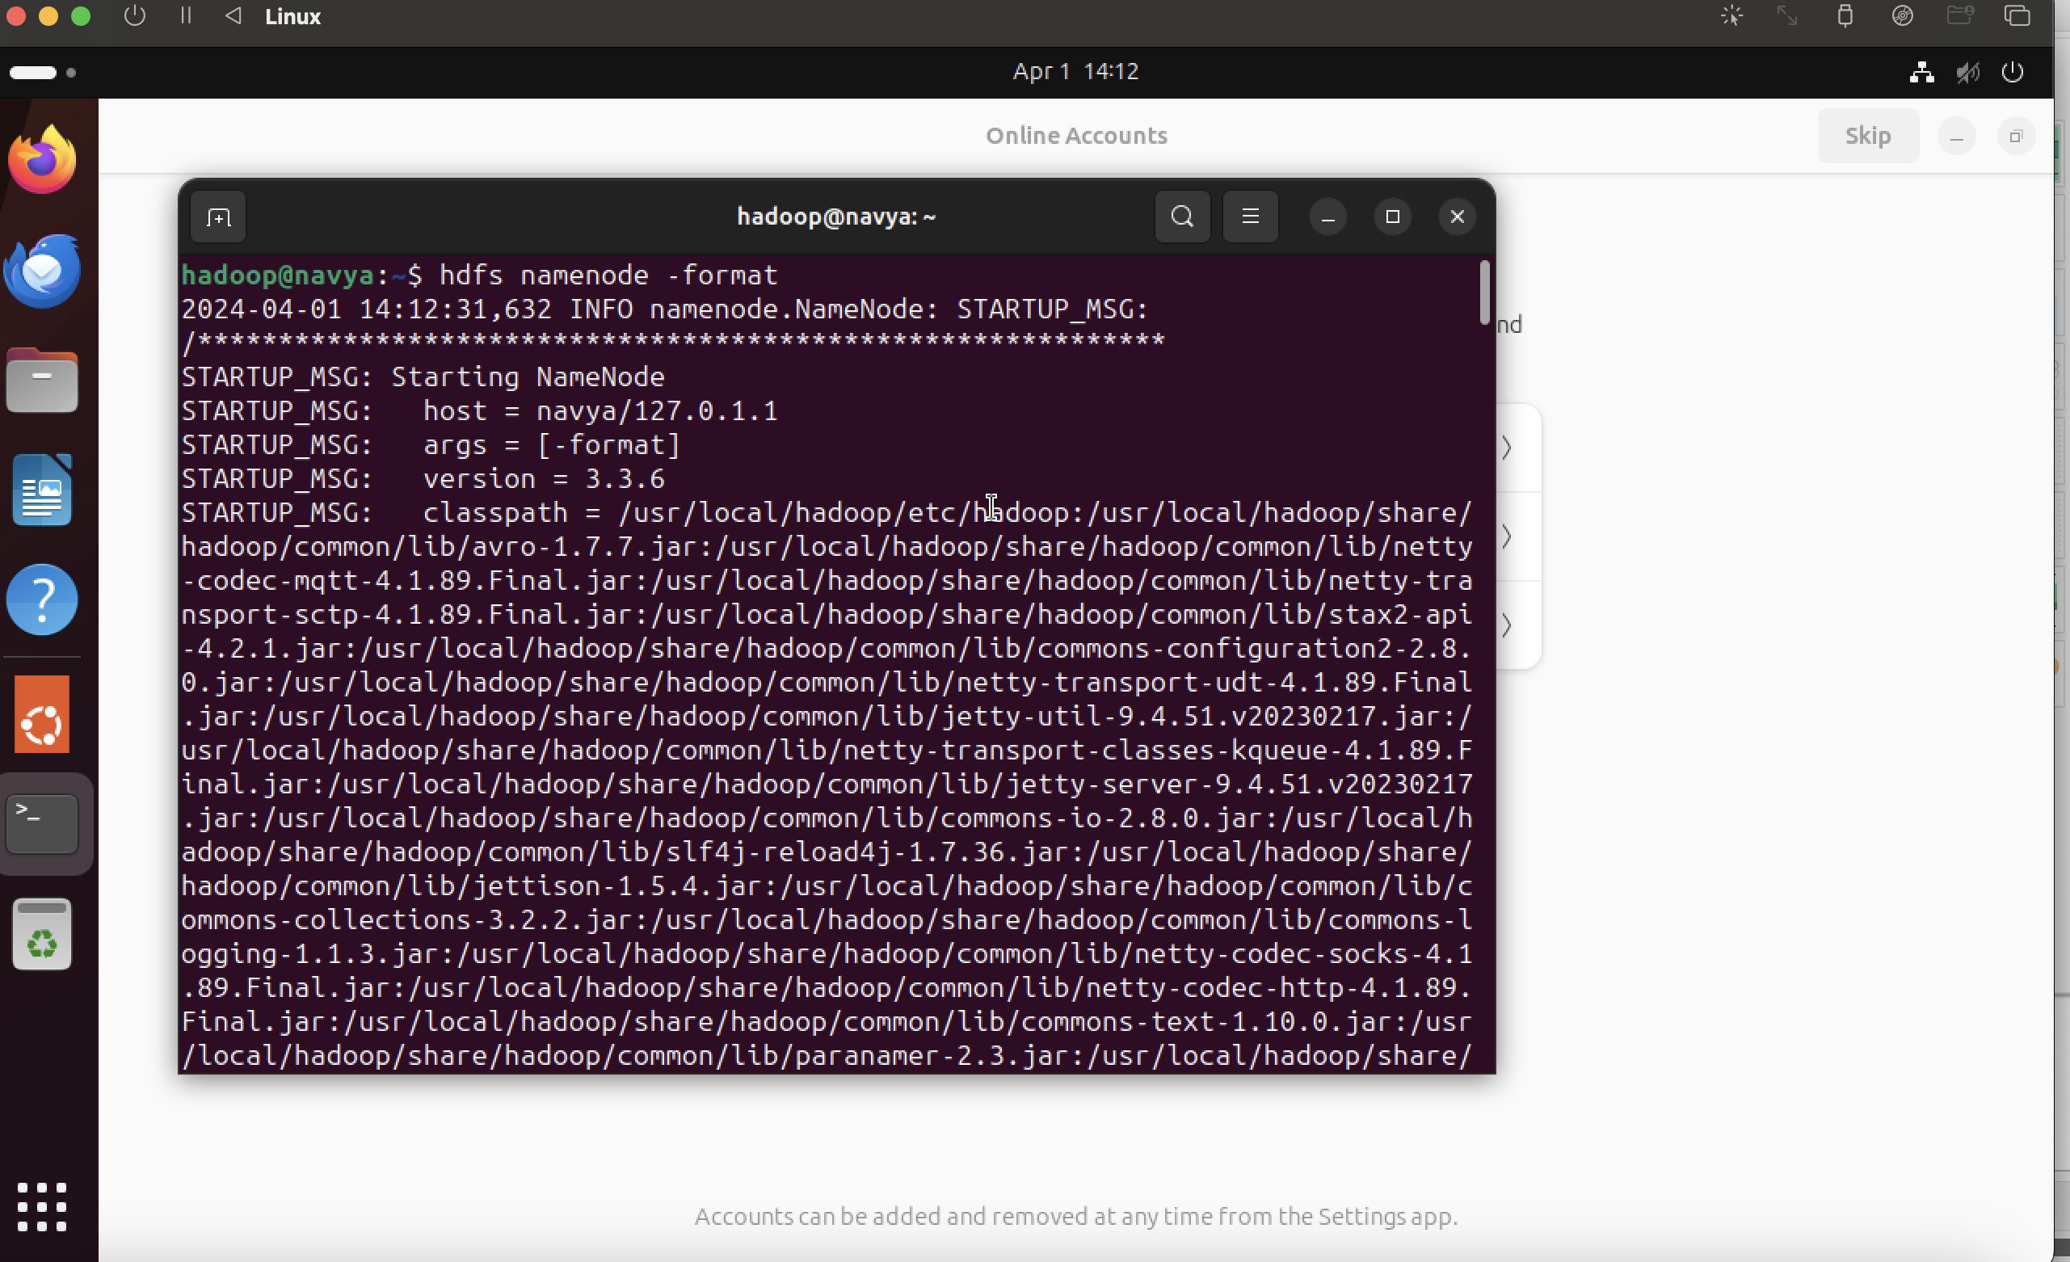

*Figure 7: Hadoop NameNode*

Apache Spark Installation

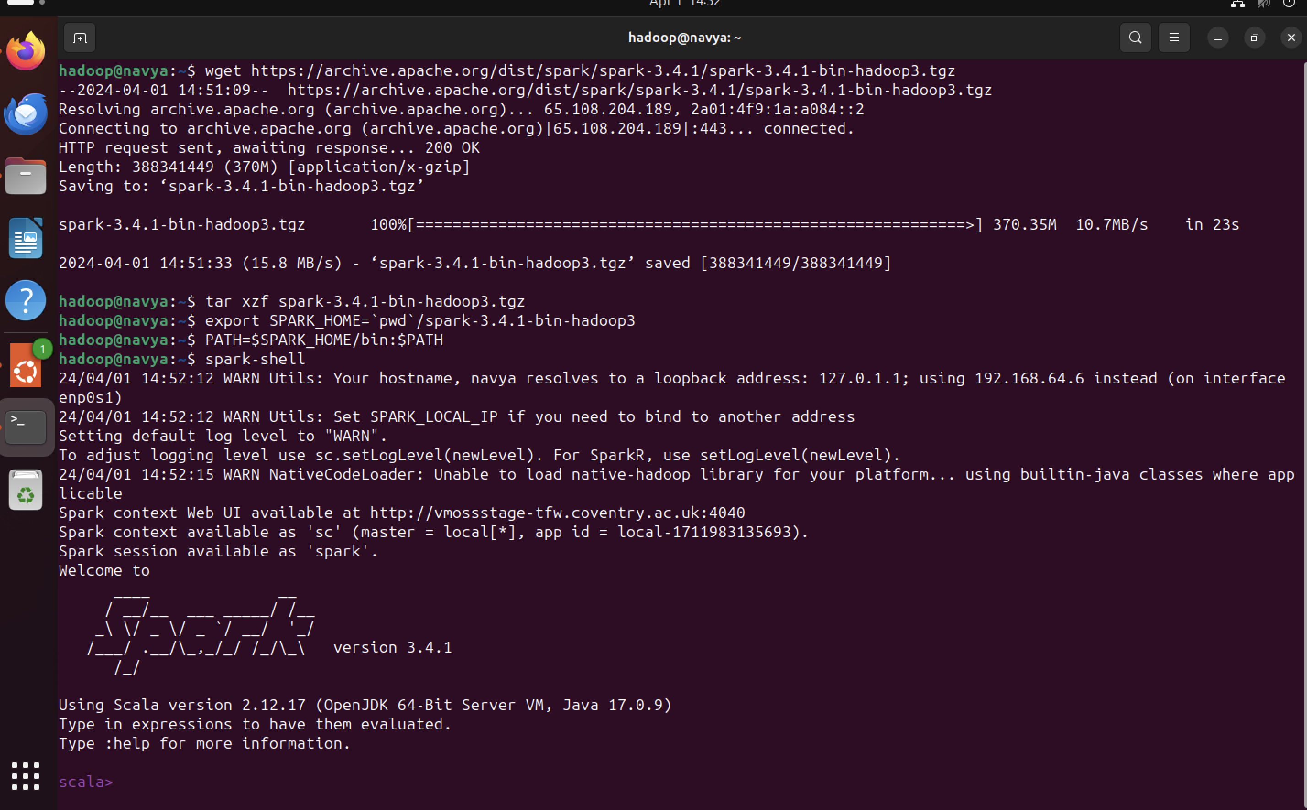

*Figure 8: Spark Installation*

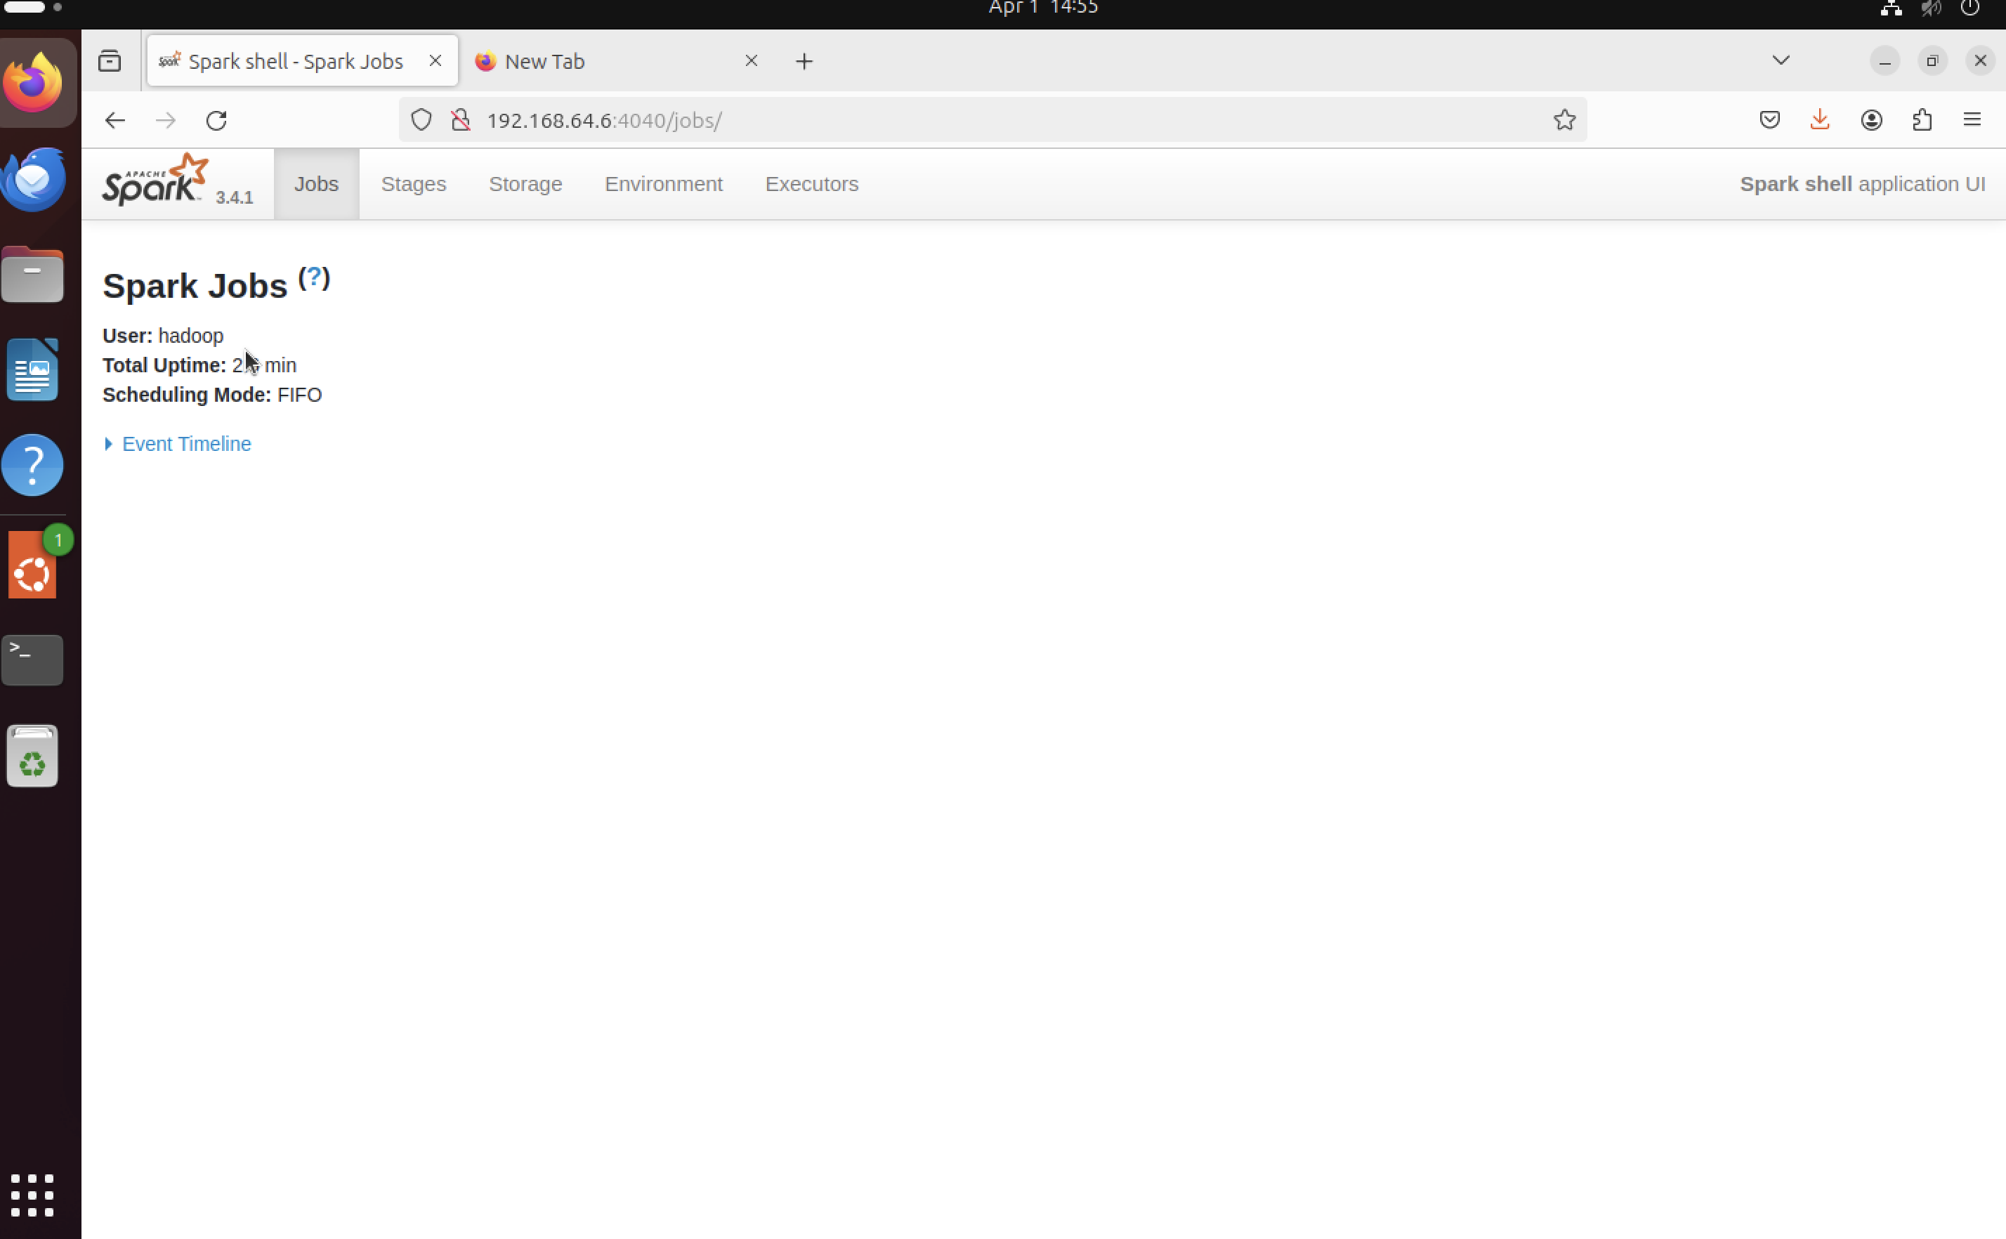

*Figure 9: Spark UI*

Tableau

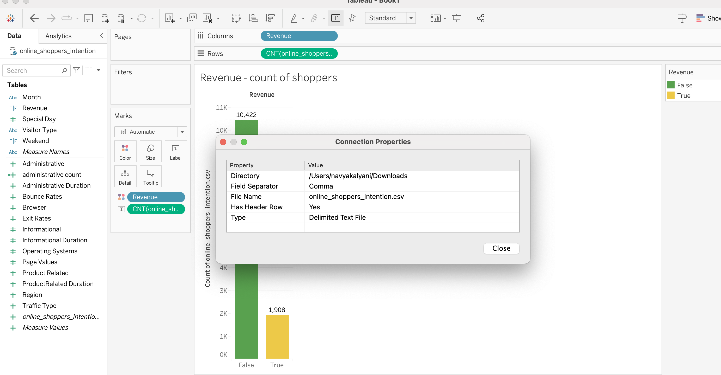

*Figure 10: Tableau*

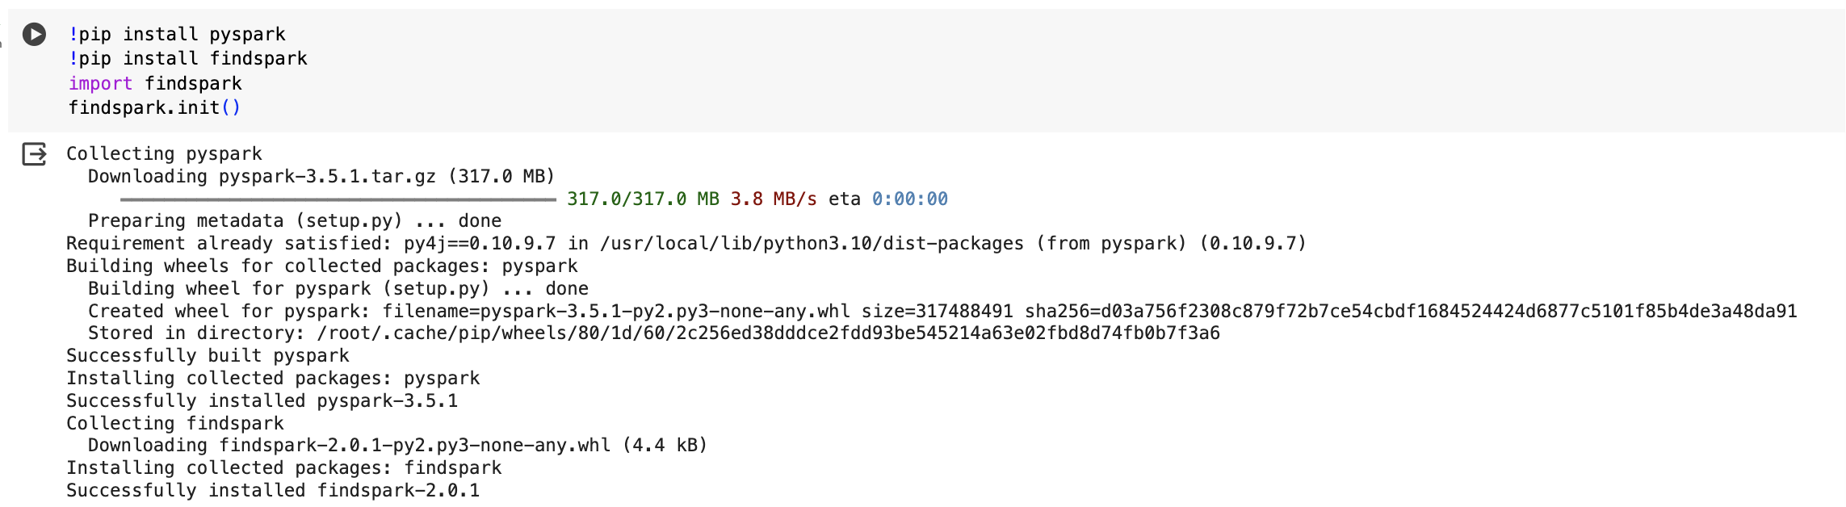

*Figure 11: Pyspark installation in google collab*

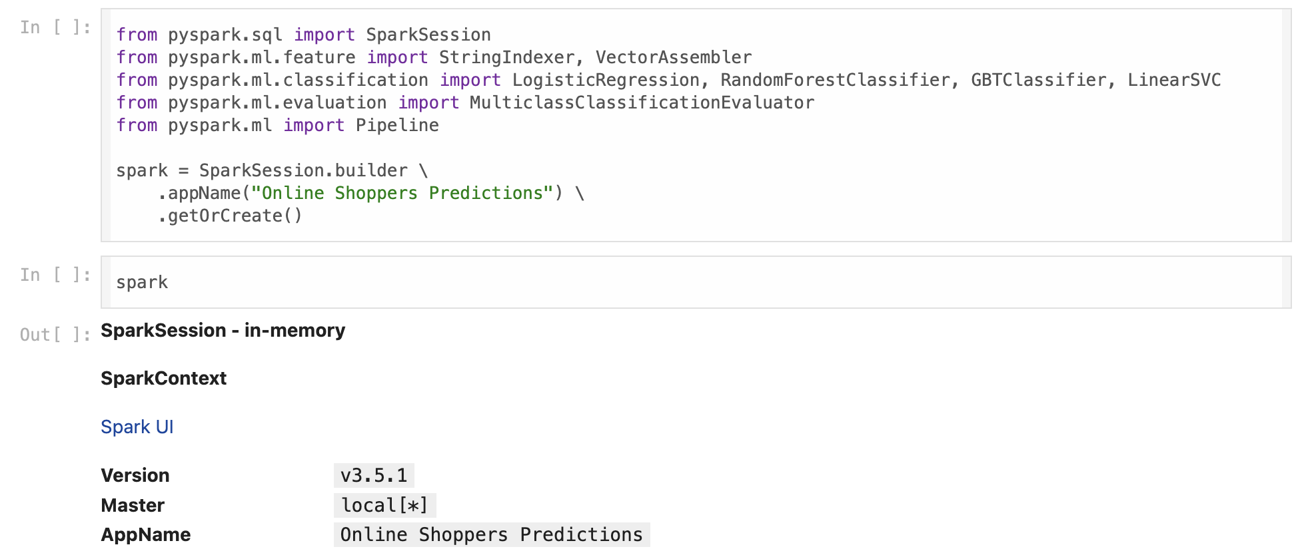

*Figure 12: Importing Pyspark Libraries*



*Figure 13: Load CSV file*

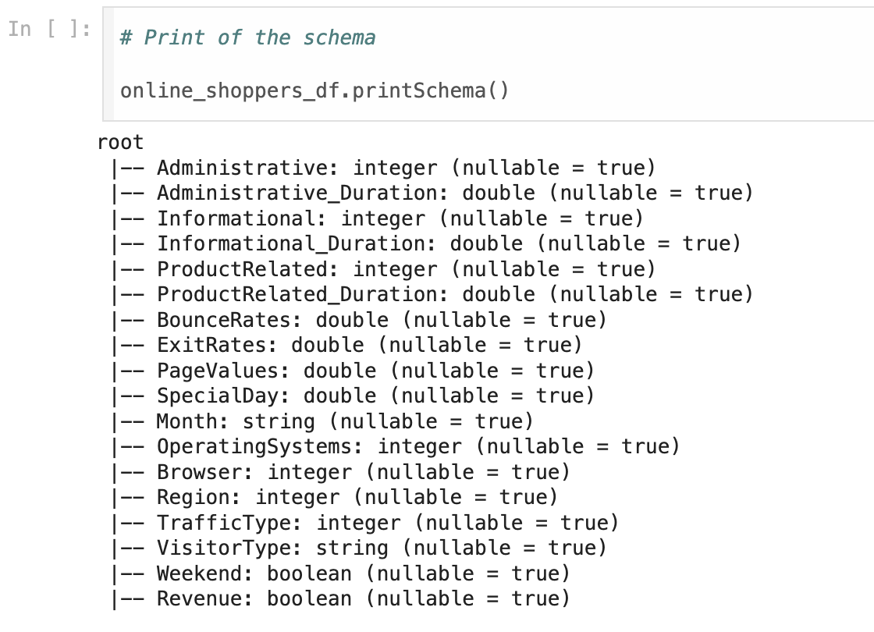

*Figure 14: Print the schema of Dataframe*

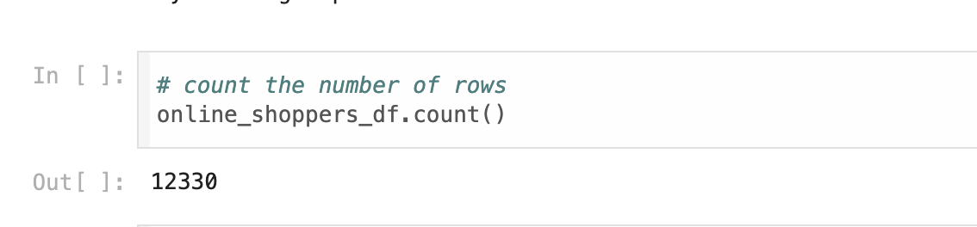

*Figure 15: Count the number of rows*

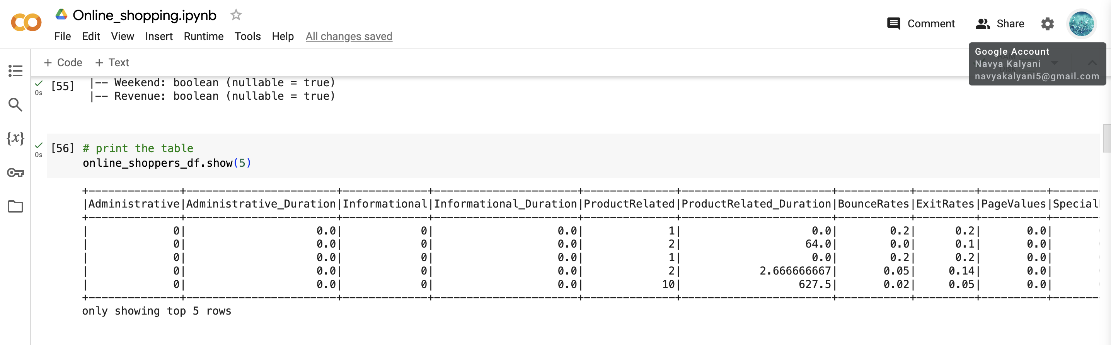

*Figure 16: Display the dataframe*

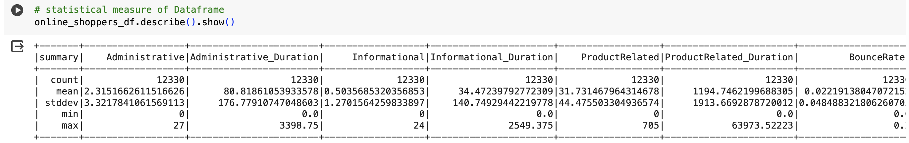

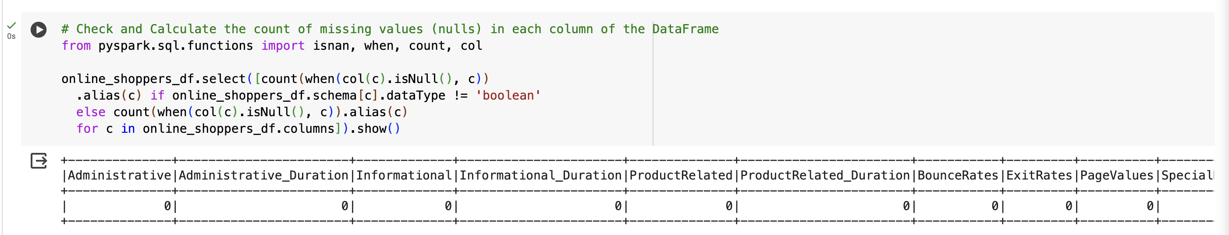

*Figure 17: Check and calculate the count of missing values of each column*

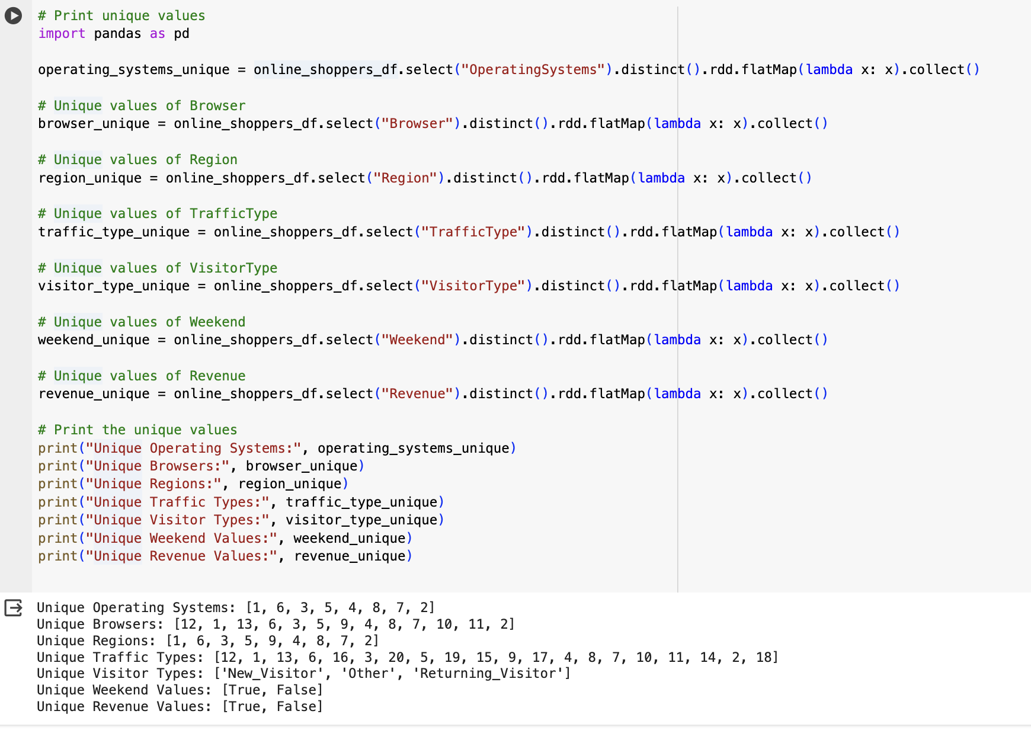

*Figure 17.1 : Print the unique values of OperatingSystems, Browser,Region,TrafficType, VisitorType, Weekend, Revenue*

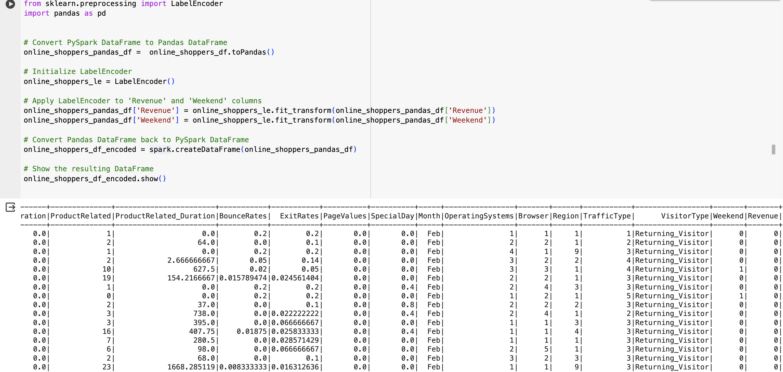

*Figure 18: Applying the Label Encoder on Revenue and Weekend displaying encoded dataframe*

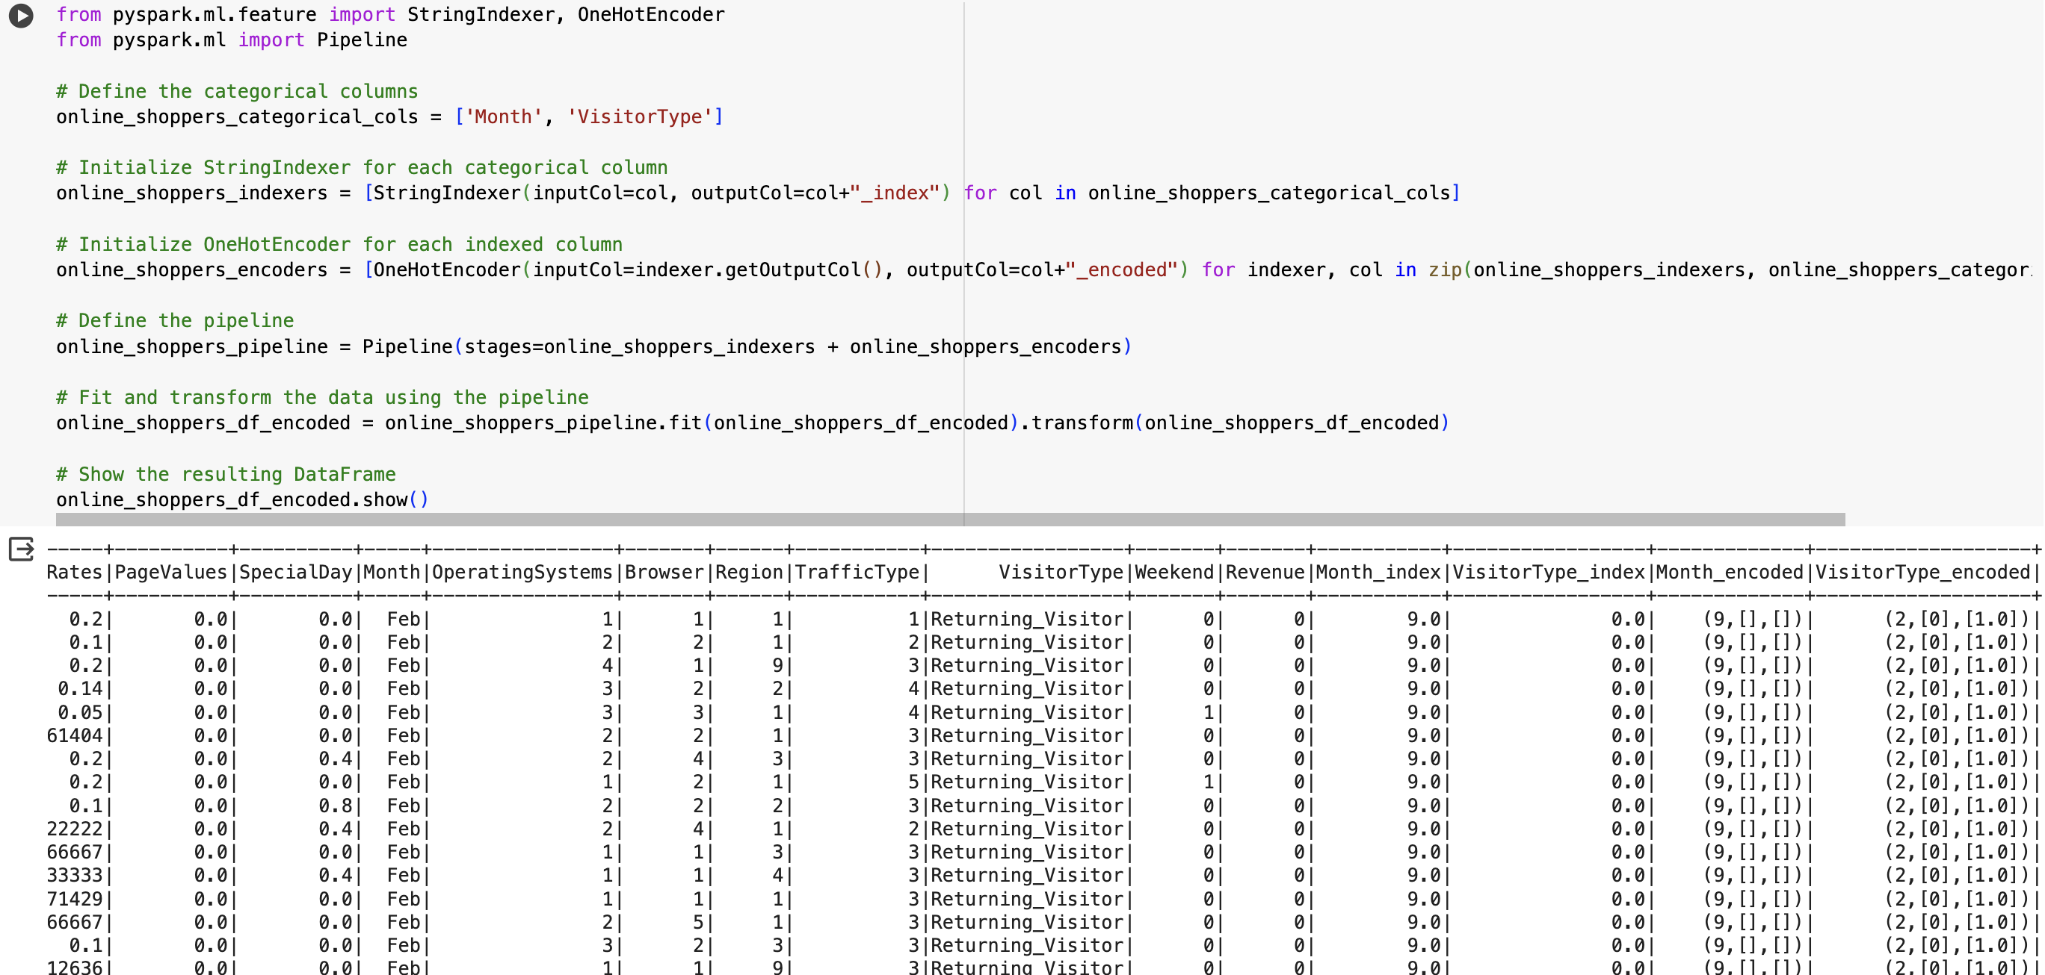

*Figure 19: Performing the One Hot encoding on Month and Visitor Type and Creating and fitting a pipeline and displaying encoded dataframe*

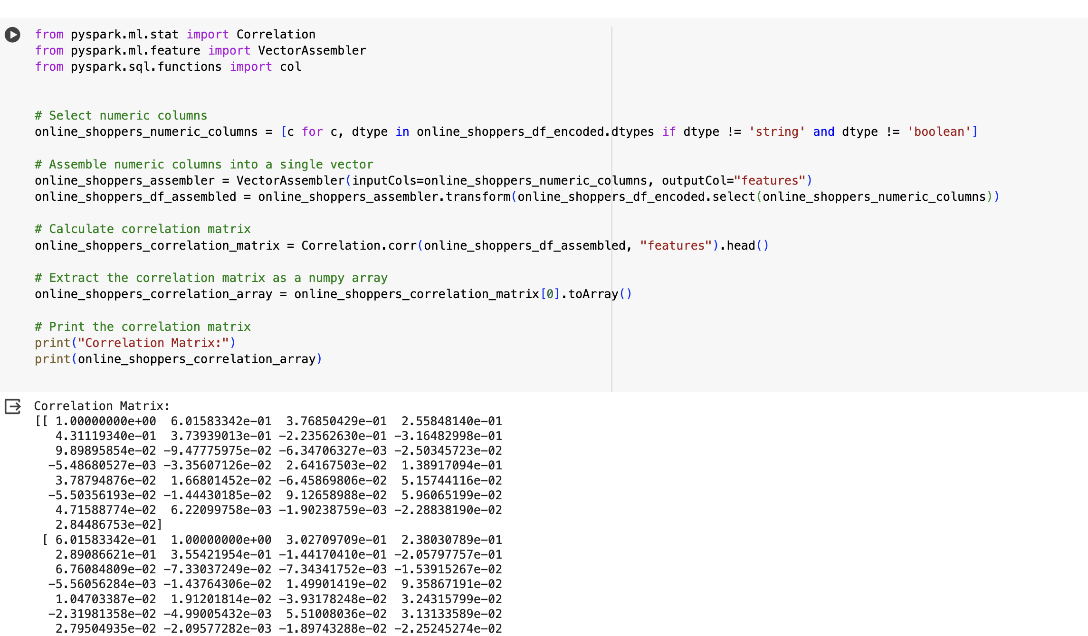

*Figure 20: Performing the single vector by VectorAssembler and calculating the correlation matrix*

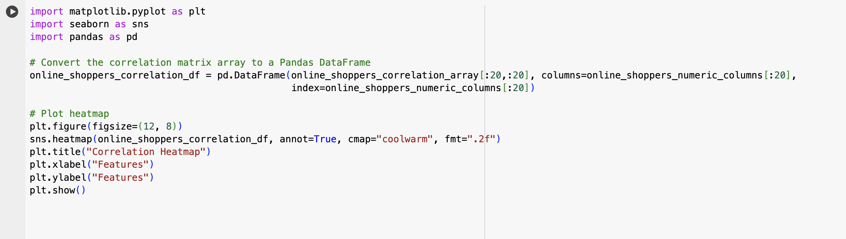

*Figure 21: Plot the Heatmap of Correlation arrays*

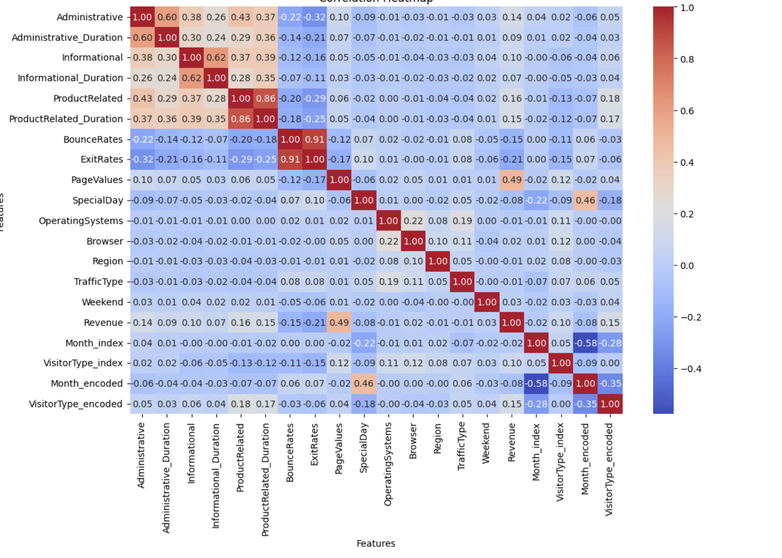

*Figure 22: Heatmap of Correlation arrays*

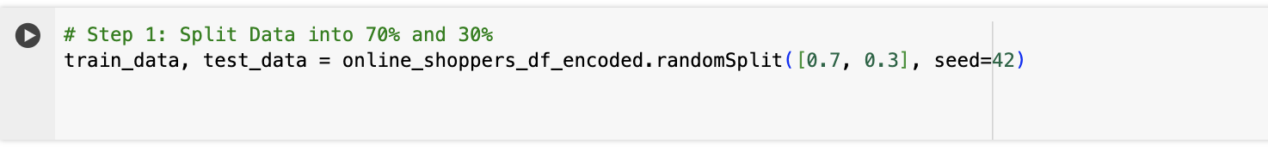

*Figure 23: Train and Test split with 70% and 30%*

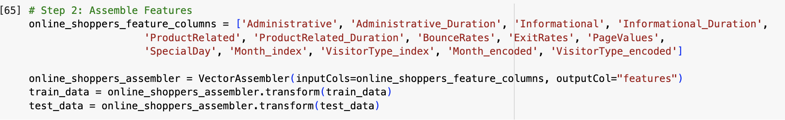

*Figure 24: Assembling the selected feature columns into a single vector column and transform Train and Test Data*

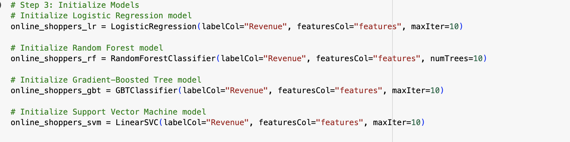

*Figure 25: Preparing the models of Logistic Regression , Random Forest, GBT Classifier, Support Vector Machine*

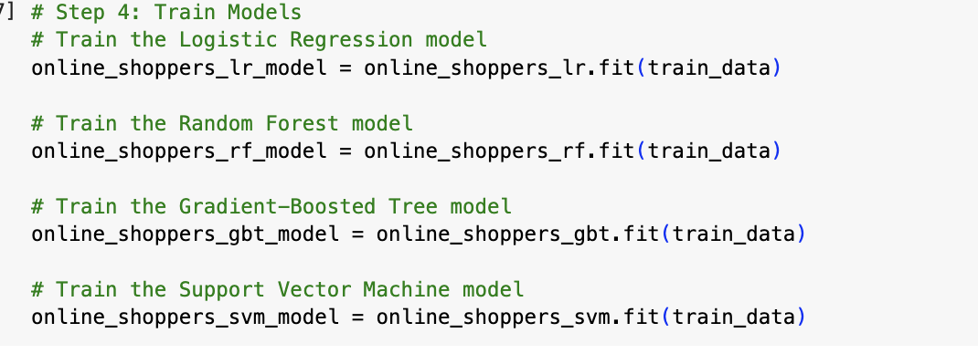

*Figure 26: Training the models*

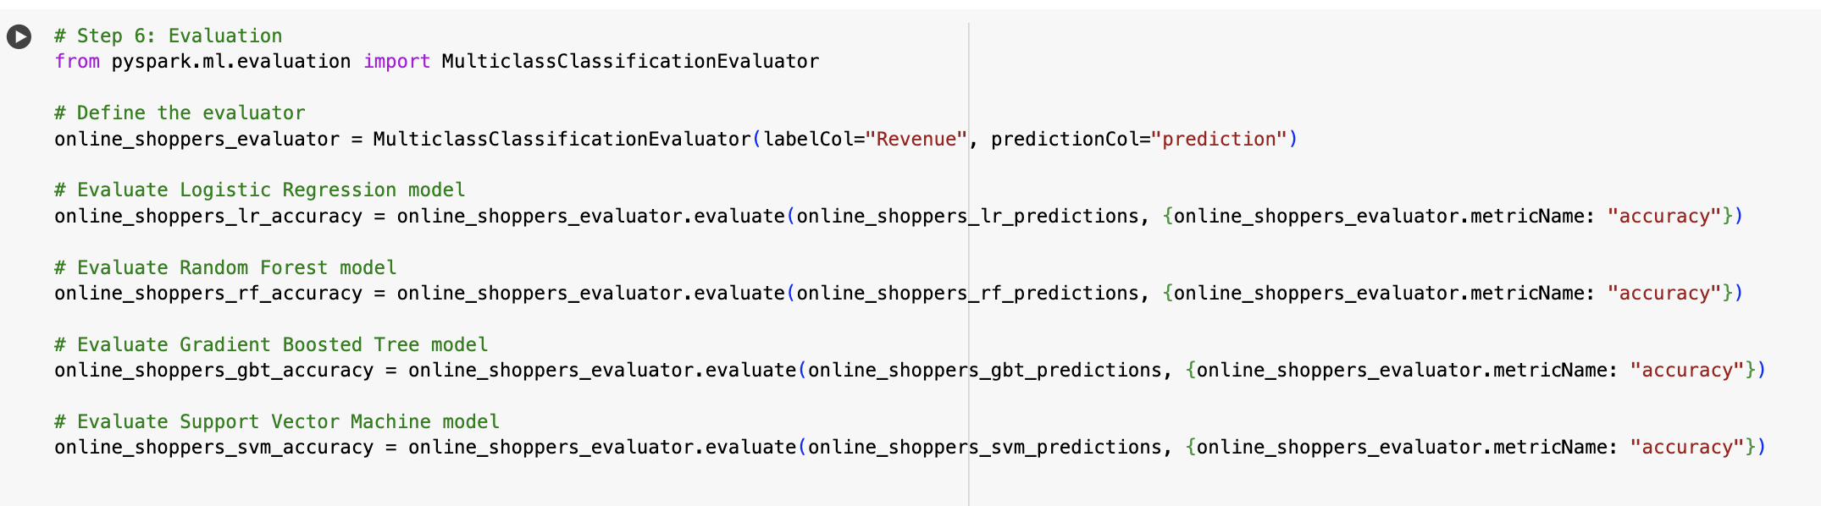

*Figure 27: Evaluating the models and finding the accuracy of each model*

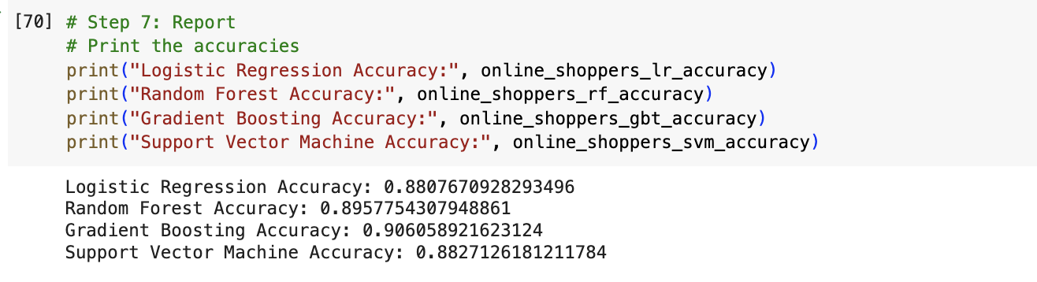

*Figure 28: Printing each model accuracy*

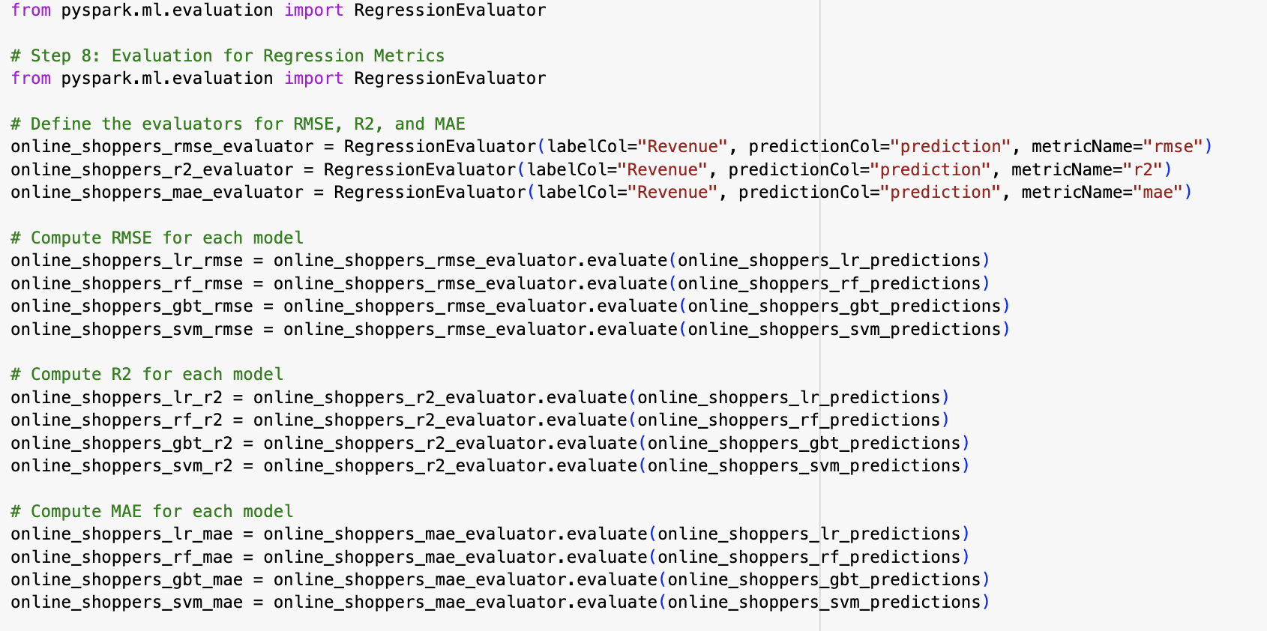

*Figure 29: Evaluating the Metrics and Computing Root Mean Squared Error, Mean Absolute Error and R-squared*

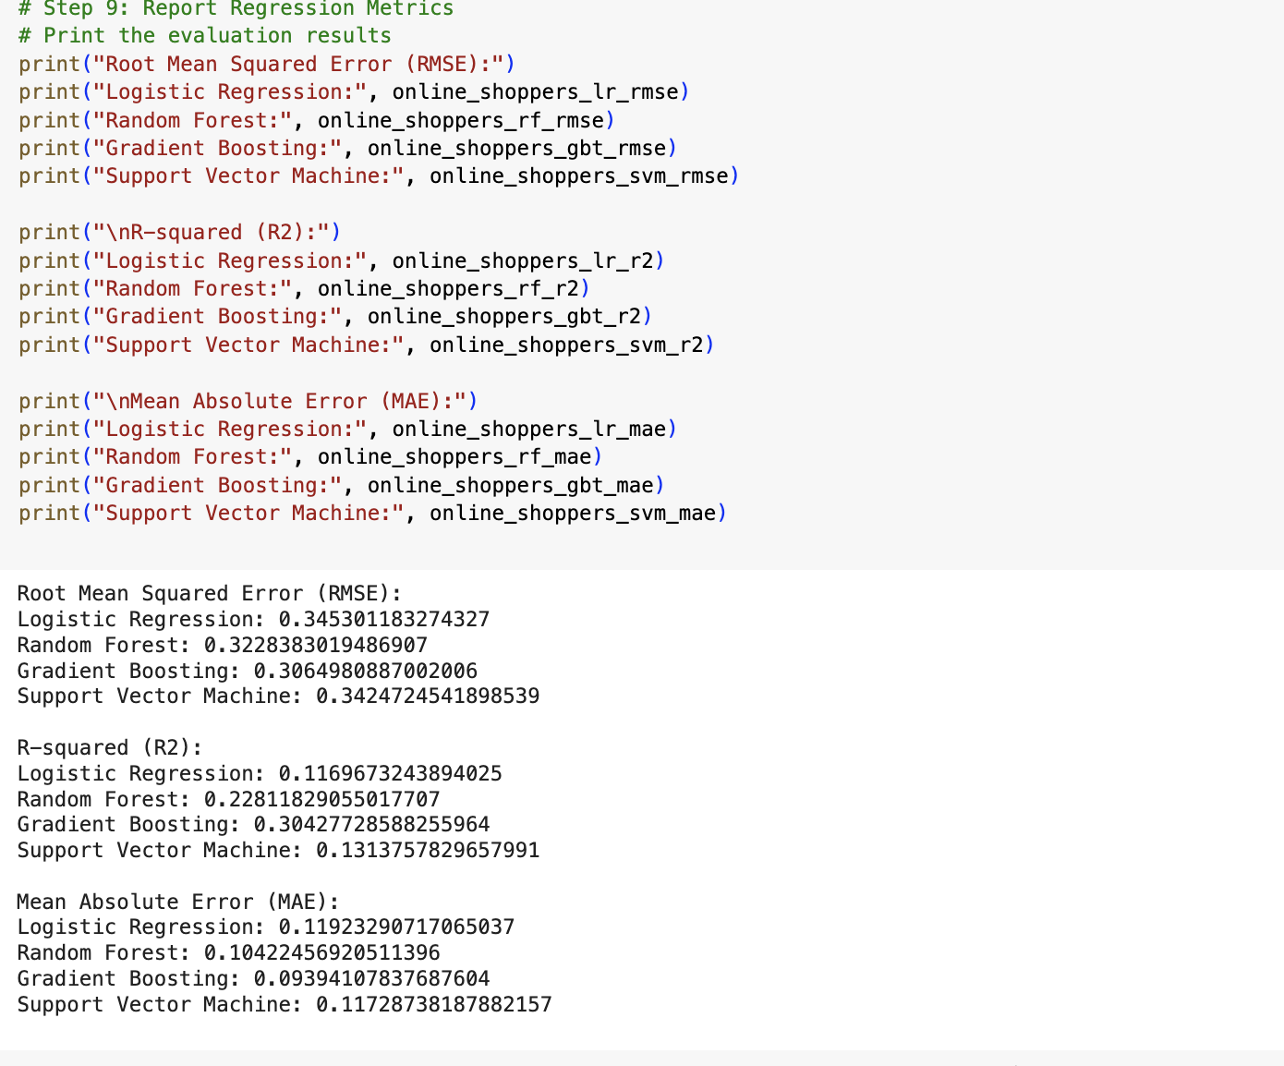

*Figure 30: Printing the Metrics Outputs*

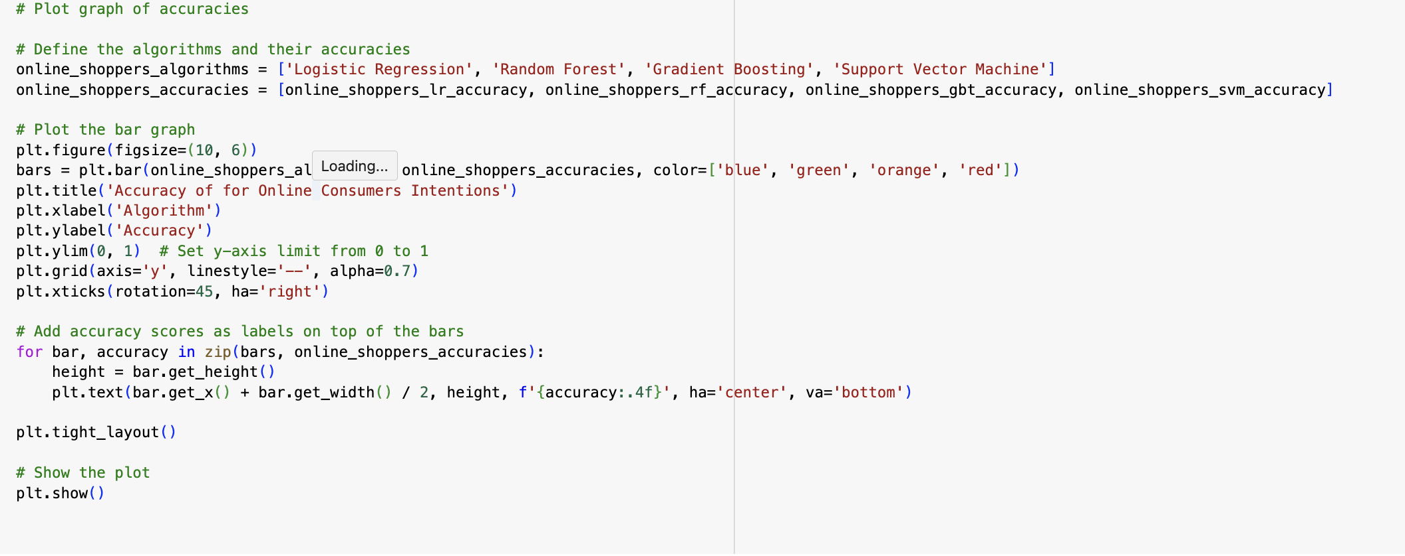

*Figure 31: Plot graph for accuracy*

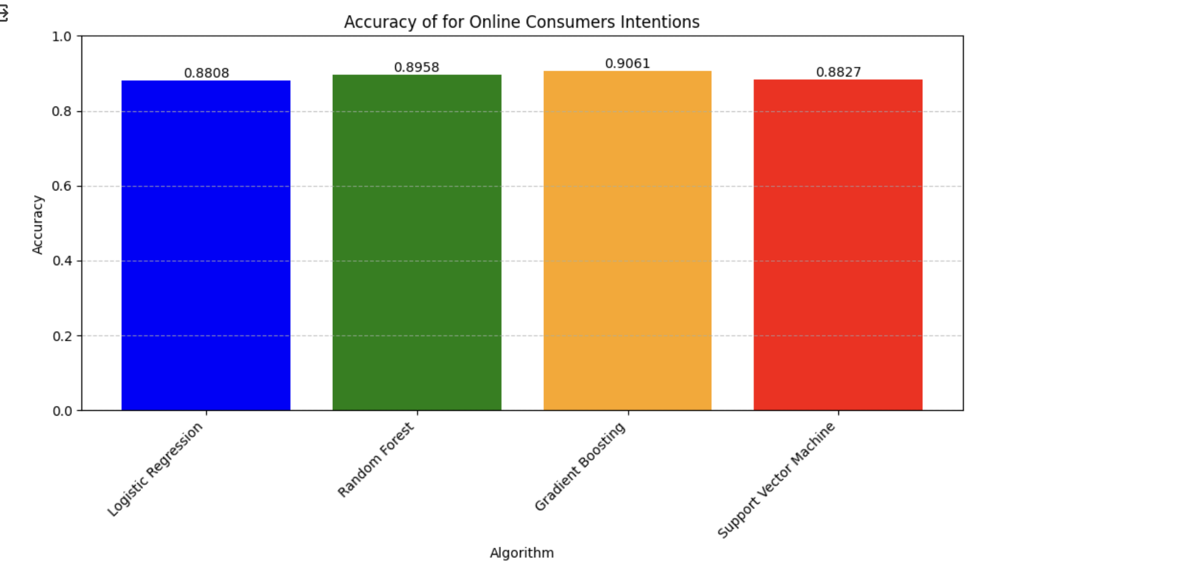

*Figure 32: Bar graph showing accuracy of four models*

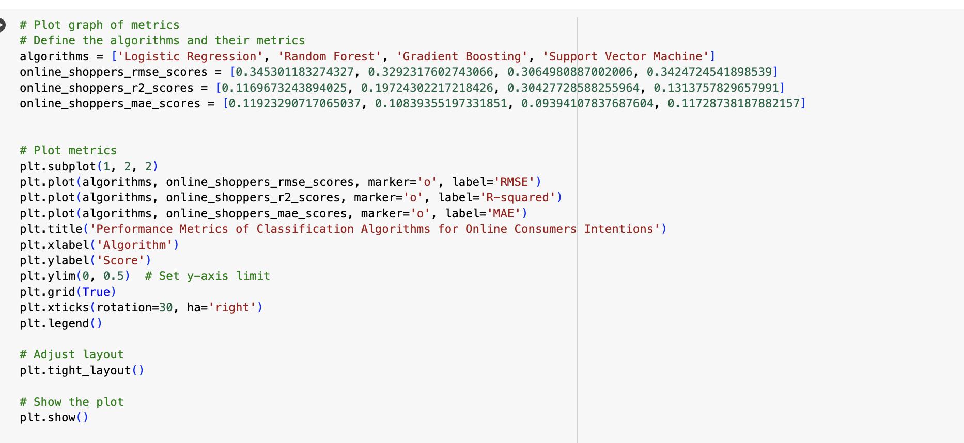

*Figure 33: Plot the graph of Metrics of each model*

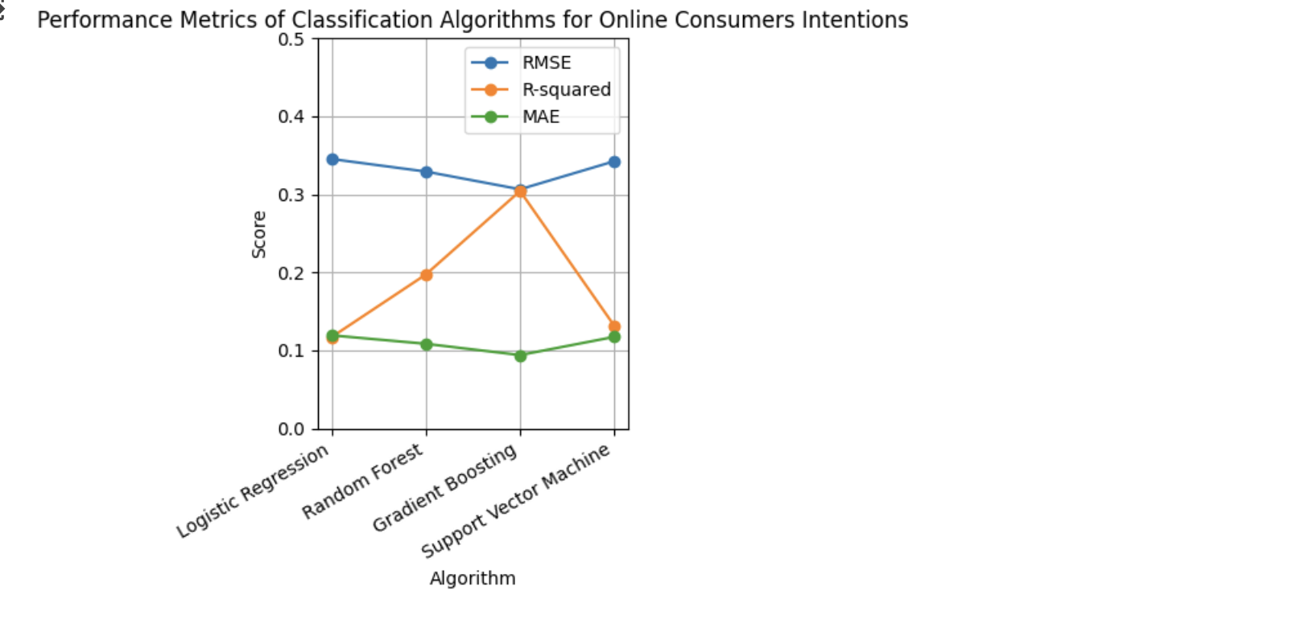

*Figure 34: Subplot of Metrics of each model*

!pip install pyspark

!pip install findspark

import findspark

findspark.init()

from pyspark.sql import SparkSession

from pyspark.ml.feature import StringIndexer, VectorAssembler

from pyspark.ml.classification import LogisticRegression, RandomForestClassifier, GBTClassifier, LinearSVC

from pyspark.ml.evaluation import MulticlassClassificationEvaluator

from pyspark.ml import Pipeline

spark = SparkSession.builder \

.appName("Online Shoppers Predictions") \

.getOrCreate()

*# load csv*

online_shoppers_df = spark.read.format("csv").load("/content/online_shoppers_intention.csv", header=True, inferSchema=True)

*# Print of the schema*

online_shoppers_df.printSchema()

*# print the table*

online_shoppers_df.show(5)

*# count the number of rows*

online_shoppers_df.count()

online_shoppers_df.describe().show()

*# Check and Calculate the count of missing values (nulls) in each column of the DataFrame*

from pyspark.sql.functions import isnan, when, count, col

online_shoppers_df.select([count(when(col(c).isNull(), c))

.alias(c) if online_shoppers_df.schema[c].dataType != 'boolean'

else count(when(col(c).isNull(), c)).alias(c)

for c in online_shoppers_df.columns]).show()

In [ ]:

from sklearn.preprocessing import LabelEncoder

import pandas as pd

*# Convert PySpark DataFrame to Pandas DataFrame*

online_shoppers_pandas_df = online_shoppers_df.toPandas()

*# Initialize LabelEncoder*

online_shoppers_le = LabelEncoder()

*# Apply LabelEncoder to 'Revenue' and 'Weekend' columns*

online_shoppers_pandas_df['Revenue'] = online_shoppers_le.fit_transform(online_shoppers_pandas_df['Revenue'])

online_shoppers_pandas_df['Weekend'] = online_shoppers_le.fit_transform(online_shoppers_pandas_df['Weekend'])

*# Convert Pandas DataFrame back to PySpark DataFrame*

online_shoppers_df_encoded = spark.createDataFrame(online_shoppers_pandas_df)

*# Show the resulting DataFrame*

online_shoppers_df_encoded.show()

from pyspark.ml.feature import StringIndexer, OneHotEncoder

from pyspark.ml import Pipeline

*# Define the categorical columns*

online_shoppers_categorical_cols = ['Month', 'VisitorType']

*# Initialize StringIndexer for each categorical column*

online_shoppers_indexers = [StringIndexer(inputCol=col, outputCol=col+"_index") for col in online_shoppers_categorical_cols]

*# Initialize OneHotEncoder for each indexed column*

online_shoppers_encoders = [OneHotEncoder(inputCol=indexer.getOutputCol(), outputCol=col+"_encoded") for indexer, col in zip(online_shoppers_indexers, online_shoppers_categorical_cols)]

*# Define the pipeline*

online_shoppers_pipeline = Pipeline(stages=online_shoppers_indexers + online_shoppers_encoders)

*# Fit and transform the data using the pipeline*

online_shoppers_df_encoded = online_shoppers_pipeline.fit(online_shoppers_df_encoded).transform(online_shoppers_df_encoded)

*# Show the resulting DataFrame*

online_shoppers_df_encoded.show()

from pyspark.ml.stat import Correlation

from pyspark.ml.feature import VectorAssembler

from pyspark.sql.functions import col

*# Select numeric columns*

online_shoppers_numeric_columns = [c for c, dtype in online_shoppers_df_encoded.dtypes if dtype != 'string' and dtype != 'boolean']

*# Assemble numeric columns into a single vector*

online_shoppers_assembler = VectorAssembler(inputCols=online_shoppers_numeric_columns, outputCol="features")

online_shoppers_df_assembled = online_shoppers_assembler.transform(online_shoppers_df_encoded.select(online_shoppers_numeric_columns))

*# Calculate correlation matrix*

online_shoppers_correlation_matrix = Correlation.corr(online_shoppers_df_assembled, "features").head()

*# Extract the correlation matrix as a numpy array*

online_shoppers_correlation_array = online_shoppers_correlation_matrix[0].toArray()

*# Print the correlation matrix*

print("Correlation Matrix:")

print(online_shoppers_correlation_array)

import matplotlib.pyplot as plt

import seaborn as sns

import pandas as pd

*# Convert the correlation matrix array to a Pandas DataFrame*

online_shoppers_correlation_df = pd.DataFrame(online_shoppers_correlation_array[:20,:20], columns=online_shoppers_numeric_columns[:20], index=online_shoppers_numeric_columns[:20])

*# Plot heatmap*

plt.figure(figsize=(12, 8))

sns.heatmap(online_shoppers_correlation_df, annot=True, cmap="coolwarm", fmt=".2f")

plt.title("Correlation Heatmap")

plt.xlabel("Features")

plt.ylabel("Features")

plt.show()

*# Step 1: Split Data into 70% and 30%*

train_data, test_data = online_shoppers_df_encoded.randomSplit([0.7, 0.3], seed=42)

*# Step 2: Assemble Features*

online_shoppers_feature_columns = ['Administrative', 'Administrative_Duration', 'Informational', 'Informational_Duration',

'ProductRelated', 'ProductRelated_Duration', 'BounceRates', 'ExitRates', 'PageValues',

'SpecialDay', 'Month_index', 'VisitorType_index', 'Month_encoded', 'VisitorType_encoded']

online_shoppers_assembler = VectorAssembler(inputCols=online_shoppers_feature_columns, outputCol="features")

train_data = online_shoppers_assembler.transform(train_data)

test_data = online_shoppers_assembler.transform(test_data)

In [ ]:

*# Step 3: Initialize Models*

*# Initialize Logistic Regression model*

online_shoppers_lr = LogisticRegression(labelCol="Revenue", featuresCol="features", maxIter=10)

*# Initialize Random Forest model*

online_shoppers_rf = RandomForestClassifier(labelCol="Revenue", featuresCol="features", numTrees=10)

*# Initialize Gradient-Boosted Tree model*

online_shoppers_gbt = GBTClassifier(labelCol="Revenue", featuresCol="features", maxIter=10)

*# Initialize Support Vector Machine model*

online_shoppers_svm = LinearSVC(labelCol="Revenue", featuresCol="features", maxIter=10)

*# Step 4: Train Models*

*# Train the Logistic Regression model*

online_shoppers_lr_model = online_shoppers_lr.fit(train_data)

*# Train the Random Forest model*

online_shoppers_rf_model = online_shoppers_rf.fit(train_data)

*# Train the Gradient-Boosted Tree model*

online_shoppers_gbt_model = online_shoppers_gbt.fit(train_data)

*# Train the Support Vector Machine model*

online_shoppers_svm_model = online_shoppers_svm.fit(train_data)

*# Step 5: Make Predictions*

*# Make predictions using the Logistic Regression model*

online_shoppers_lr_predictions = online_shoppers_lr_model.transform(test_data)

*# Make predictions using the Random Forest model*

online_shoppers_rf_predictions = online_shoppers_rf_model.transform(test_data)

*# Make predictions using the Gradient-Boosted Tree model*

online_shoppers_gbt_predictions = online_shoppers_gbt_model.transform(test_data)

*# Make predictions using the Support Vector Machine model*

online_shoppers_svm_predictions = online_shoppers_svm_model.transform(test_data)

*# Step 6: Evaluation*

from pyspark.ml.evaluation import MulticlassClassificationEvaluator

*# Define the evaluator*

online_shoppers_evaluator = MulticlassClassificationEvaluator(labelCol="Revenue", predictionCol="prediction")

*# Evaluate Logistic Regression model*

online_shoppers_lr_accuracy = online_shoppers_evaluator.evaluate(online_shoppers_lr_predictions, {online_shoppers_evaluator.metricName: "accuracy"})

*# Evaluate Random Forest model*

online_shoppers_rf_accuracy = online_shoppers_evaluator.evaluate(online_shoppers_rf_predictions, {online_shoppers_evaluator.metricName: "accuracy"})

*# Evaluate Gradient Boosted Tree model*

online_shoppers_gbt_accuracy = online_shoppers_evaluator.evaluate(online_shoppers_gbt_predictions, {online_shoppers_evaluator.metricName: "accuracy"})

*# Evaluate Support Vector Machine model*

online_shoppers_svm_accuracy = online_shoppers_evaluator.evaluate(online_shoppers_svm_predictions, {online_shoppers_evaluator.metricName: "accuracy"})

*# Step 7: Report*

*# Print the accuracies*

print("Logistic Regression Accuracy:", online_shoppers_lr_accuracy)

print("Random Forest Accuracy:", online_shoppers_rf_accuracy)

print("Gradient Boosting Accuracy:", online_shoppers_gbt_accuracy)

print("Support Vector Machine Accuracy:", online_shoppers_svm_accuracy)

from pyspark.ml.evaluation import RegressionEvaluator

*# Step 8: Evaluation for Regression Metrics*

from pyspark.ml.evaluation import RegressionEvaluator

*# Define the evaluators for RMSE, R2, and MAE*

online_shoppers_rmse_evaluator = RegressionEvaluator(labelCol="Revenue", predictionCol="prediction", metricName="rmse")

online_shoppers_r2_evaluator = RegressionEvaluator(labelCol="Revenue", predictionCol="prediction", metricName="r2")

online_shoppers_mae_evaluator = RegressionEvaluator(labelCol="Revenue", predictionCol="prediction", metricName="mae")

*# Compute RMSE for each model*

online_shoppers_lr_rmse = online_shoppers_rmse_evaluator.evaluate(online_shoppers_lr_predictions)

online_shoppers_rf_rmse = online_shoppers_rmse_evaluator.evaluate(online_shoppers_rf_predictions)

online_shoppers_gbt_rmse = online_shoppers_rmse_evaluator.evaluate(online_shoppers_gbt_predictions)

online_shoppers_svm_rmse = online_shoppers_rmse_evaluator.evaluate(online_shoppers_svm_predictions)

*# Compute R2 for each model*

online_shoppers_lr_r2 = online_shoppers_r2_evaluator.evaluate(online_shoppers_lr_predictions)

online_shoppers_rf_r2 = online_shoppers_r2_evaluator.evaluate(online_shoppers_rf_predictions)

online_shoppers_gbt_r2 = online_shoppers_r2_evaluator.evaluate(online_shoppers_gbt_predictions)

online_shoppers_svm_r2 = online_shoppers_r2_evaluator.evaluate(online_shoppers_svm_predictions)

*# Compute MAE for each model*

online_shoppers_lr_mae = online_shoppers_mae_evaluator.evaluate(online_shoppers_lr_predictions)

online_shoppers_rf_mae = online_shoppers_mae_evaluator.evaluate(online_shoppers_rf_predictions)

online_shoppers_gbt_mae = online_shoppers_mae_evaluator.evaluate(online_shoppers_gbt_predictions)

online_shoppers_svm_mae = online_shoppers_mae_evaluator.evaluate(online_shoppers_svm_predictions)

*# Step 9: Report Regression Metrics*

*# Print the evaluation results*

print("Root Mean Squared Error (RMSE):")

print("Logistic Regression:", online_shoppers_lr_rmse)

print("Random Forest:", online_shoppers_rf_rmse)

print("Gradient Boosting:", online_shoppers_gbt_rmse)

print("Support Vector Machine:", online_shoppers_svm_rmse)

print("\nR-squared (R2):")

print("Logistic Regression:", online_shoppers_lr_r2)

print("Random Forest:", online_shoppers_rf_r2)

print("Gradient Boosting:", online_shoppers_gbt_r2)

print("Support Vector Machine:", online_shoppers_svm_r2)

print("\nMean Absolute Error (MAE):")

print("Logistic Regression:", online_shoppers_lr_mae)

print("Random Forest:", online_shoppers_rf_mae)

print("Gradient Boosting:", online_shoppers_gbt_mae)

print("Support Vector Machine:", online_shoppers_svm_mae)

*# Plot graph of accuracies*

*# Define the algorithms and their accuracies*

online_shoppers_algorithms = ['Logistic Regression', 'Random Forest', 'Gradient Boosting', 'Support Vector Machine']

online_shoppers_accuracies = [online_shoppers_lr_accuracy, online_shoppers_rf_accuracy, online_shoppers_gbt_accuracy, online_shoppers_svm_accuracy]

*# Plot the bar graph*

plt.figure(figsize=(10, 6))

bars = plt.bar(online_shoppers_algorithms, online_shoppers_accuracies, color=['blue', 'green', 'orange', 'red'])

plt.title('Accuracy of for Online Consumers Intentions')

plt.xlabel('Algorithm')

plt.ylabel('Accuracy')

plt.ylim(0, 1) *# Set y-axis limit from 0 to 1*

plt.grid(axis='y', linestyle='--', alpha=0.7)

plt.xticks(rotation=45, ha='right')

*# Add accuracy scores as labels on top of the bars*

for bar, accuracy in zip(bars, online_shoppers_accuracies):

height = bar.get_height()

plt.text(bar.get_x() + bar.get_width() / 2, height, f'{accuracy:.4f}', ha='center', va='bottom')

plt.tight_layout()

*# Show the plot*

plt.show()

*# Plot graph of metrics*

*# Define the algorithms and their metrics*

algorithms = ['Logistic Regression', 'Random Forest', 'Gradient Boosting', 'Support Vector Machine']

online_shoppers_rmse_scores = [0.345301183274327, 0.3292317602743066, 0.3064980887002006, 0.3424724541898539]

online_shoppers_r2_scores = [0.1169673243894025, 0.19724302217218426, 0.30427728588255964, 0.1313757829657991]

online_shoppers_mae_scores = [0.11923290717065037, 0.10839355197331851, 0.09394107837687604, 0.11728738187882157]

*# Plot metrics*

plt.subplot(1, 2, 2)

plt.plot(algorithms, online_shoppers_rmse_scores, marker='o', label='RMSE')

plt.plot(algorithms, online_shoppers_r2_scores, marker='o', label='R-squared')

plt.plot(algorithms, online_shoppers_mae_scores, marker='o', label='MAE')

plt.title('Performance Metrics of Classification Algorithms for Online Consumers Intentions')

plt.xlabel('Algorithm')

plt.ylabel('Score')

plt.ylim(0, 0.5) *# Set y-axis limit*

plt.grid(True)

plt.xticks(rotation=30, ha='right')

plt.legend()

*# Adjust layout*

plt.tight_layout()

*# Show the plot*

plt.show()

Github : [Code](https://github.com/kalyani234/BigData_CourseWork)